 |  |  |  | STANDARD OPERATING PROCEDURE
 |  |  |  | <Nscrypt 3dn-150-hp operation>
 | College/Dept: |  | COEN |  |  |  | Building/Room: | Eng106
 | Laboratory Name: |  | IML |  |  |  | Revision: | 1
 | Principal Investigator: |  | Pete Miranda |  |  |  | Author: | Travis
Before the worked detailed in this procedure may begin, the intended user must read and understand this document.
This document must be approved by the PI, the college’s safety liaison, and EHSS.
Any changes to this document, however minor, must be submitted for approval by the PI, the college’s safety liaison, and EHSS.
The “buddy system” will be in place whenever any work is conducted.

Approval
 | Intended User:
 |  | Name, Title |  |  |  | Signature |  |  |  | Date
 |  | Name, Title |  |  |  | Signature |  |  |  | Date
 | Reviewed and Approved by: | Pete Miranda, Director IML |  |  |  | 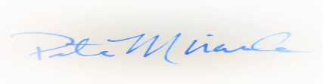 |  |  |  | 08-12-19
 |  | Name, Title |  |  |  | Signature |  |  |  | Date
 |  | Name, Title |  |  |  | Signature |  |  |  | Date

Overview
Nscrypt 3Dn-150-Hp Material Printer
Scope
Machine operation
Potential Hazards
☒ | Chemical |  | ☐ |  |  | Thermal |  |  | ☐ | Hydraulic |  |  |  |  | ☐ | Electrical | ☐ |  | Slip/Trip | ☐ | Biological
☒ | Mechanical |  | ☐ |  |  | Radiation |  |  | ☒ | Pneumatic |  |  |  |  | ☐ | Fire | ☐ |  | Fall | ☒ | Other
Hazard Specifics: |  |  |  | Chemical- Ink/Paste dependent. User’s responsibility to read SDS and understand hazards.  Mechanical- Stage movement/pinch hazards  Pneumatic- Compressed air used for paste delivery  Laser-
Engineering Controls (EC)
☒ | Fume hood |  |  |  | ☐ |  | Biosafety Cabinet |  |  |  |  | ☐ |  | Other Local Exhaust |  |  |  | ☒ | Shielding | ☐ | Other
EC Specifics: |  | Fume Hood- used for filling ink/paste syringes  Shielding- machine encased in glass to protect users while machine is in use
Training Requirements – except for classroom lab safety, must be completed prior to performing the procedure
☒ | Classroom Laboratory Safety Awareness |  |  |  |  |  |  |  |  |  | ☐ |  | Radiation Worker
☐ | Online Safety Topics (specify):
☒ | Lab/Work Group Specific Training (specify): Machine setup and user training provided by IML Staff. Observed operation of machine until IML Staff comfortable with user operation.
☐ | Other (specify):

Personal Protective Equipment (PPE)
☒ |  | Safety glasses |  | ☐ | Safety goggles |  | ☐ | Face shield & safety glasses |  |  |  |  | ☐ |  | Face shield & safety goggles
☒ |  | Lab coat |  | ☐ | Apron |  | ☐ | Tyvek suit |  |  |  |  | ☐ |  | Tyvek sleeves
☒ |  | Gloves |  | ☐ | Leg coverings |  | ☐ | Hard hat |  |  |  |  | ☐ |  | Hearing protection
☐ |  | Respirator |  | ☐ | Shoes | ☐ |  | Fall protection |  |  |  |  |  | ☐ | Other
PPE Description: |  |  |  | Safety Glasses required. Available in ENG106  Lab Coat Required when loading syringe. Available in ENG106  Nitril/latex gloves required. Available in ENG106
Equipment, Materials, Supplies, & Facility Requirements
Handling, Work Area & Storage Requirements
No Ink/paste storage allowed in eng106
Emergency Response Equipment & Supplies
☒ |  | Eyewash |  | ☒ | Fire extinguisher |  |  |  | ☒ | First aid kit | ☐ | Calcium gluconate gel (HF use)
☒ |  | Safety shower |  | ☐ | Fire blanket |  |  |  | ☐ | Spill kit | ☐ | Emergency gas shutoffs
☐ |  | Drench hose |  | ☐ | Other:
Description: |  |  | Eye Wash, Safety Shower, Fire Extinguisher, and First Aid kit available in eng106.
Decontamination & Waste Disposal
Solvent Trash available in eng106. User must fill out trash log sheet. IML Staff to properly dispose of trash as necessary.
 | Spill Response
 | Wipes and cleaning chemical available. Notify IML Staff
Additional Safety Information
Review of applicable safety references such as material safety data sheets to ensure appropriate protective measures, spill supplies, and first aid procedures.
References
NScrypt Machine Users Guide

Procedure
STEPS
 | Potential Hazards | EC, Haz. Mitigation Device, PPE
- Syringe Assembly | Chemical | Ventilation Hood  Gloves  Safety Glasses  Lab Coat
- Obtain dispensing syringe with plug, filling syringe, and coupler from RUCH 106.
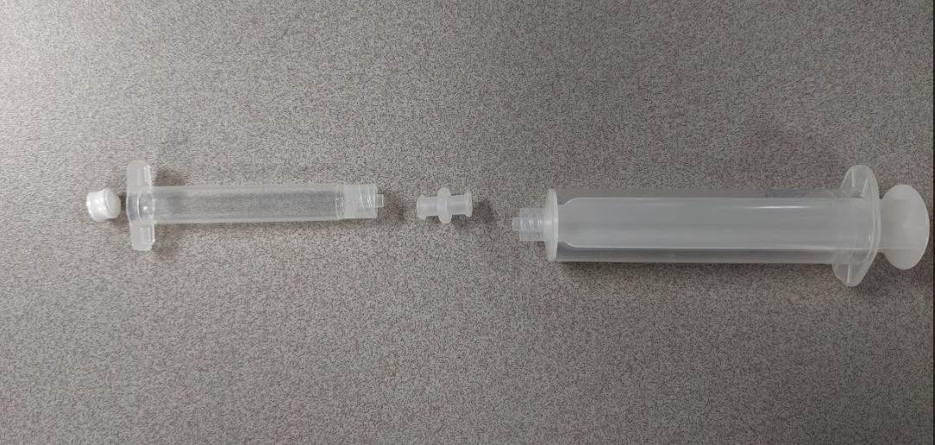
- Under a fume hood ink/paste to filling syringe minimizing amount of trapped air.
- Fully insert the plug into the dispensing syringe
- Connect dispensing syringe to filling syringe with coupler and carefully transfer material to dispensing syringe.
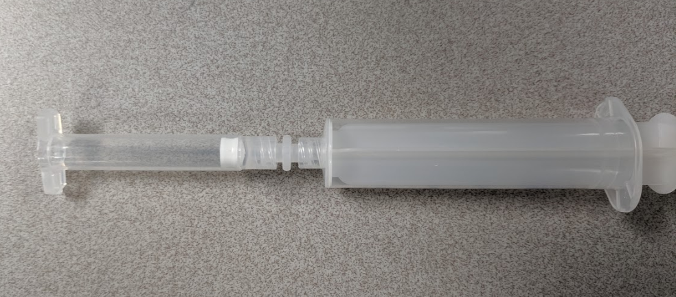
- To get satisfactory printed structures it in necessary to remove all air from syringes. Centrifuging the dispensing syringe might be necessary if working with a thick paste.
Refer to Section 2.1 of the nScrypt Machine Tool User Guide for further details regarding Syringe assembly.
Refer to Section 2.1.1 of the nScrypt Machine Tool User Guide regarding details of eliminating trapped air and centrifuging your syringe.
 | Potential Hazards | EC, Haz. Mitigation Device, PPE
- Pump Assembly | Mechanical pinch hazards | Machine Interlocks/Shielding
Obtain and inspect loaded syringe, threaded luer, valve rod, valve rod oring(-001), Delran retaining ring, valve body, oring keeper, keeper oring(-006), tip retainer, tip, and oring lube.
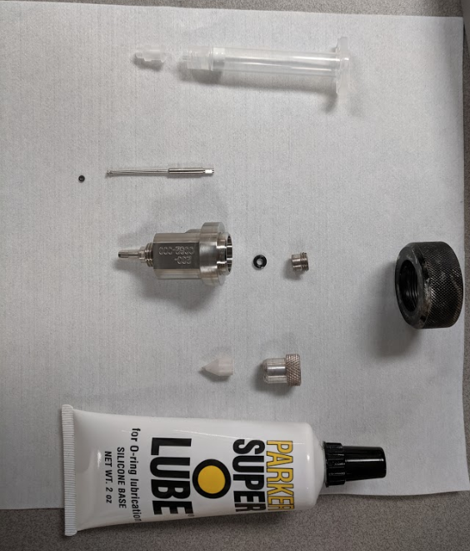

Put a small amount of oring lube on the orings.
Without damaging the oring slide the small oring into the groove on the end of the vlave rod.
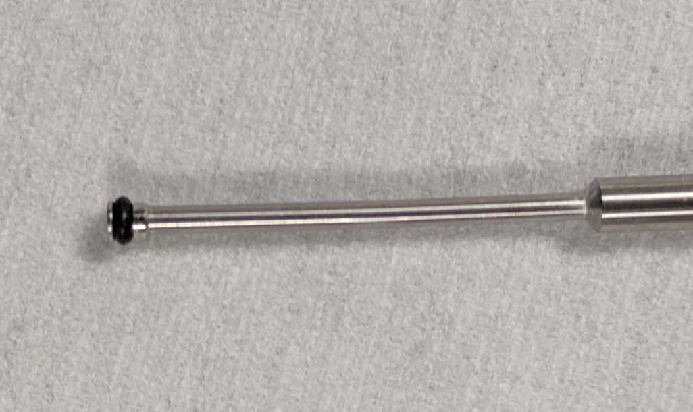
Attach the loaded valve rod to the dry pump assembly by inserting the larger end of the rod into the small circle in middle of the actuator located below the metal housing of the dry pump assembly. The rod should be hard-mounted with the shoulder of the rod in contact with the dry pump assembly. This rod is held in place by two 4-40 set screws located in the front and on the right edge of the actuator. The valve rod should be inserted into the pump with the flats aligned with the set screws. Using a 3/32nd Allen wrench tighten the right edge set screw ~1/4-1/2 turn, tighten the front set screw ~2 turns or until tighten.
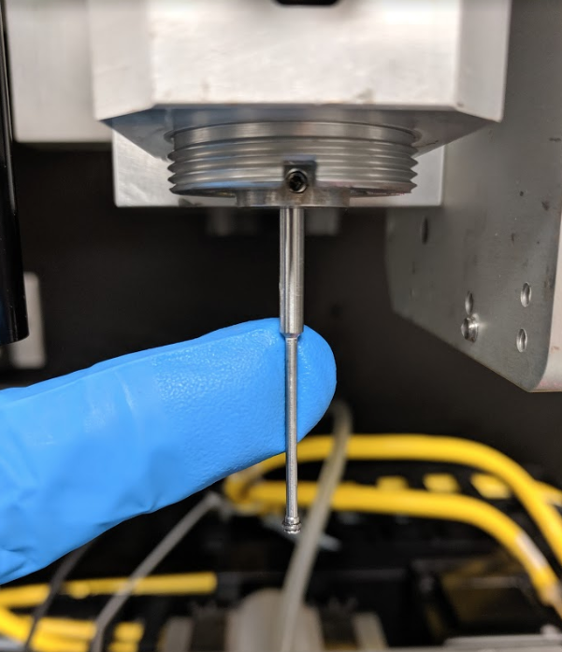
Make sure the rod shoulder is flush with the pump.

Insert the -006 O-ring into the valve body. Make sure it is centered to allow the valve rod to pass through during install.
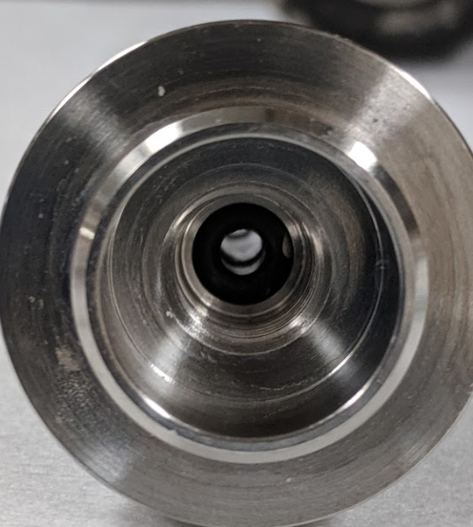

Screw the O-ring keeper into the top of the valve body. The proper position of the O-ring keeper is below the shoulder of the valve body and hand-tightened. If the oring keeper is too loose, material will be allowed to flow up into the dry pump assembly. If the oring keeper is too tight, it will compress the -006 O-ring too much and assembling the valve body on the dry pump assembly will be difficult.
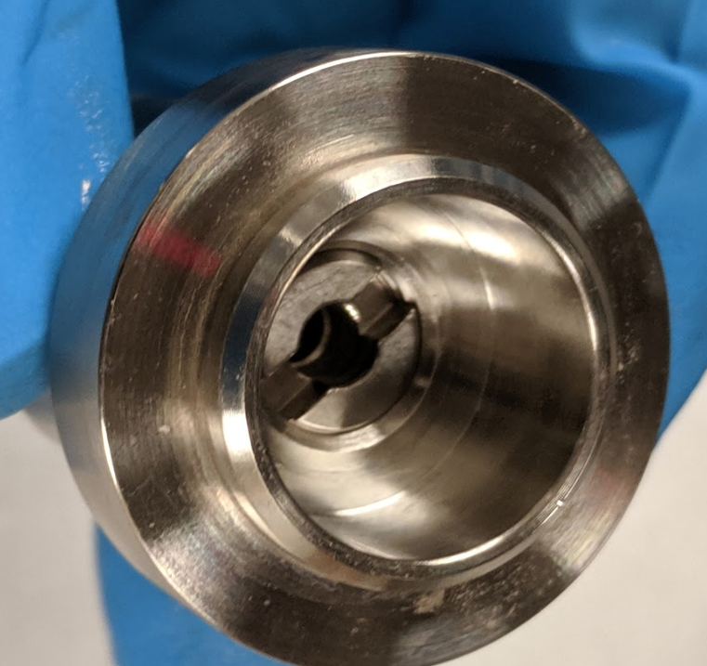
Oring keep should be below shoulder inside valve body.

Install the valve body and O-ring keeper onto the dry pump assembly. Make sure it is fully seated against the pump assembly.
Hand-tighten the Delran retaining nut holding the valve body in place against the dry pump assembly.

Insert the selected tip into the tip retainer ring. Install the tip and retainer ring on the valve body.
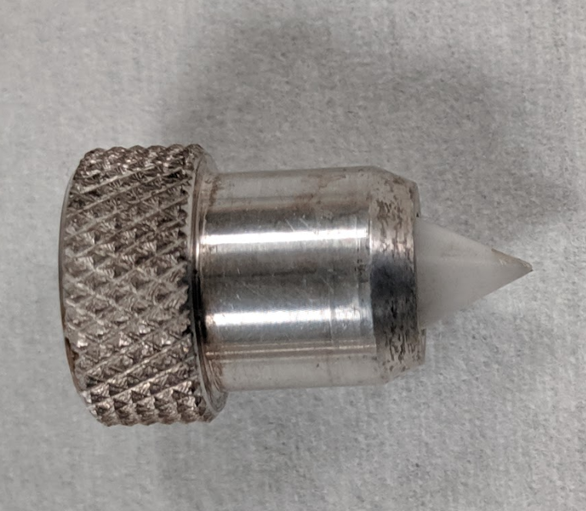

Apply the female luer to 10-32 threaded adapter. Hand tighten the threaded adapter.

Attach only the syringe (no end caps) from the syringe assembly to the Adapter

Attach the yellow pneumatic adapter to the syringe.
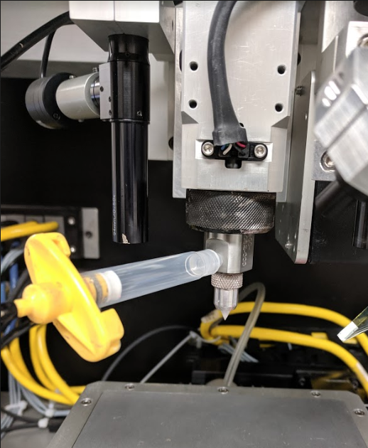

Close door
The wetted parts assembly is complete.
 | Potential Hazards | EC, Haz. Mitigation Device, PPE
- nScrypt Initial Start-up Procedure | Chemical/Pneumatic | Machine Shielding

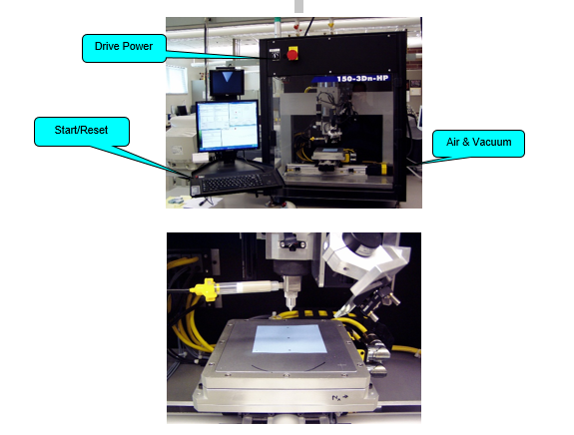
Turn on air & vacuum valve on side of machine

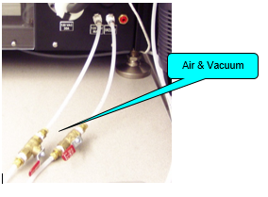
If light tower on top of printer doesn’t have any lights illuminated turn the drive power switch to the start position. It will return to the on position by itself.

If not already on. Turn on PC (Username IMLUser Password Fall2016!)
Launch Virtual machine. (Takes a few minutes)
In virtual machine window launch Nscrypt software.

Upon launching the software a “drive power problem” popup should appear. Press the red start/reset button above the keyboard and select yes on the popup.
Every time you open the front door on the printer you should see this popup. You will need to press the red start/reset button above the keyboard before accepting the popup.
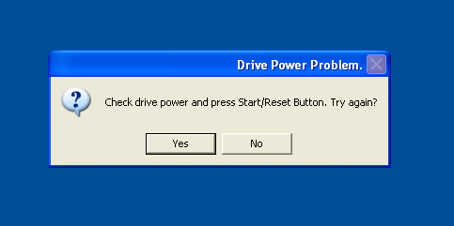

After the software launches click the Resource Control icon (gear and tools) on the nScrypt Machine Tool window
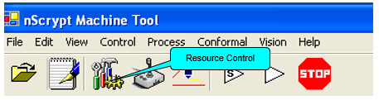
On the resources control popup click on the Y _axis tab. Check the speed setting is around 5. If it is not using the slider bar to set it ~5mm/sec. Use the negative or positive arrows to jog the y axis towards the back of the machine. The Y axis needs to be near the limit flag at the back of the machine to home properly. Click the Home XYZ tab.
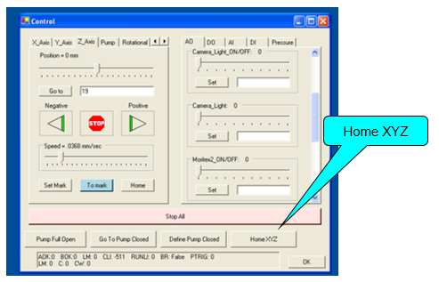
Speed setting
Y Axis Tab
Click the Pump tab on the Control window
Click the Home button to home the pump
Click the Go to pump closed button on the Control window
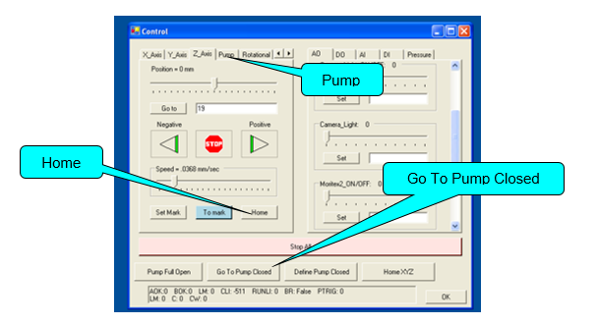
Tool is now initialized.

 | Potential Hazards | EC, Haz. Mitigation Device, PPE
- Zeroing Valve Pen/Camera/Laser | Mechanical | Machine Shielding
Switch Upper monitor to the Pen Tip view using the AV button on the remote
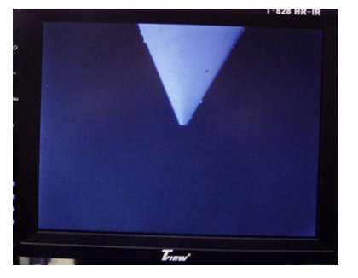
Click the AO tab on the Control window.
On the right side Scroll down to the Tip Light slider and turn on the Tip Light. Move slider to the right until you can clearly see the pen tip. (About .5)
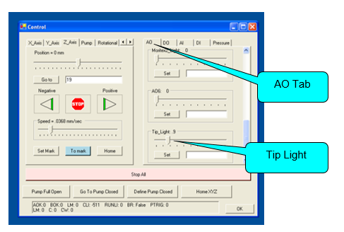
Click the Pen Control icon (two icons over from the resource icon looks somewhat like a pen) on the nScrypt Machine Tool window
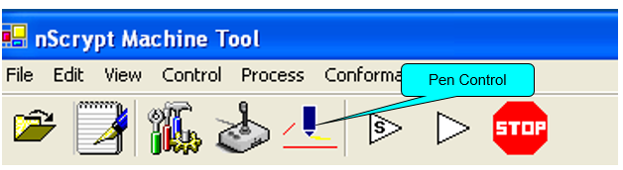
Click on the Valve Pen tab on the PenForm window. Click the Load button on the PenForm window (button will be green when the device is loaded)
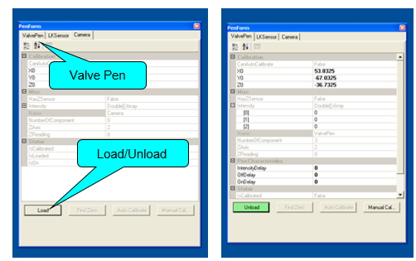

Using the X,Y tabs on the Control window move the pen tip to one side of the scribed cross (Bottom right hand corner of the stage) on the vacuum chuck.
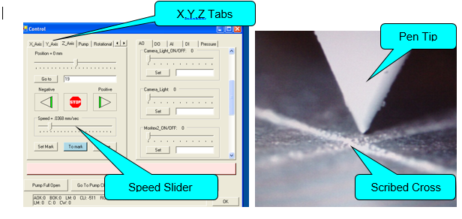
Using the Z tab on the Control window (Once the stage can be seen on the top monitor set speed slider to approximately 0.1 mm/sec)
Watching the Upper monitor move the pen tip so that it just touches the surface of the vacuum chuck
Click the Set Mark button on the Control window
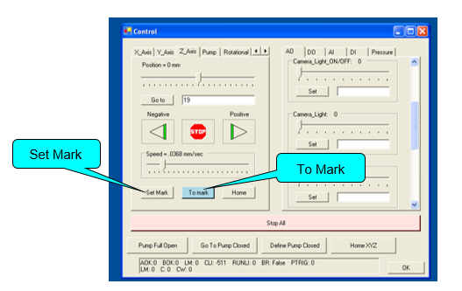
Move pen tip away (positive Z ~.5mm) from the vacuum chuck

Using the Axis controls in the control window move pen tip so that it is directly over the scribed cross
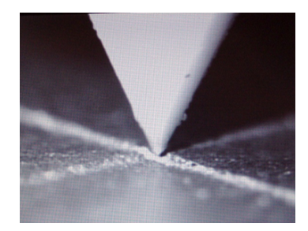
Click the Z tab then click the To Mark button on the Control window. Z axis should move down to height of the stage.
Click the Manual Calibrate button on the PenForm window to set the XYZ values for the pen tip. Positions for X0 Y0 Z0 should change to the current position of the pen tip
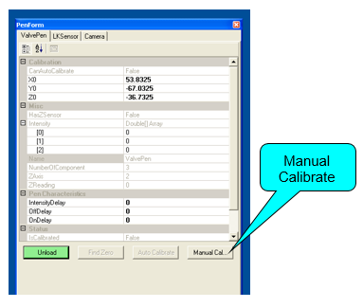
Move Z axis positive ~20mm.

Laser
Click the AI tab on the Control window
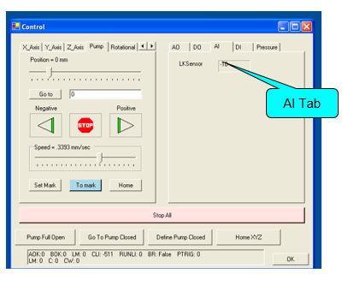
Click the LKSensor tab on the PenForm window
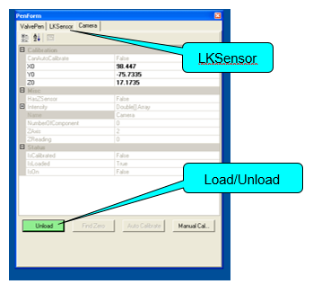
Click the Load button (button will be green when the device is loaded) on the PenForm window
Using the X,Y tabs on the Control window move the laser until it is to one side of the scribed cross on the vacuum chuck
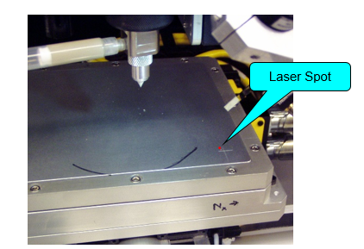
In the Z_axis tab on the ResourceControl window use the positive or negative arrows to move the laser into range. The value on the AI tab will read ~zero when the laser is in range
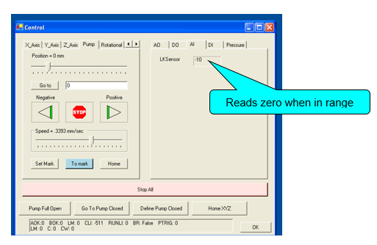
Using the X,Y tabs only move the laser until it is directly over the scribed cross on the vacuum chuck
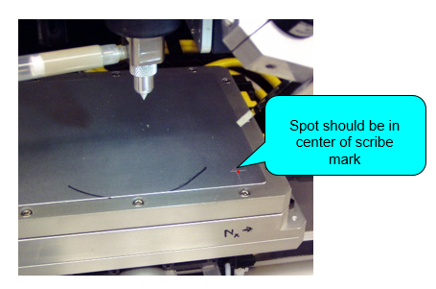

Click the Manual Calibrate button on the PenForm window to set the XYZ values for the laser
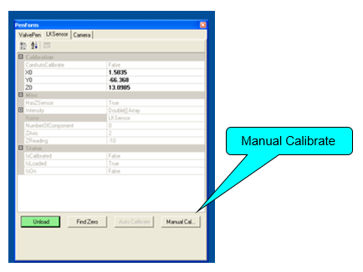

Camera
Click the AO tab on the Control window. Turn on the Camera Light (about 0.5 on the slider)
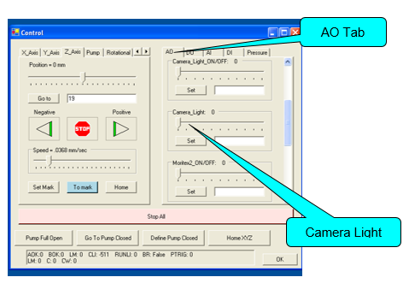
Click the Camera tab on the PenForm window. Click the Load (button will be green when the device is loaded) button on the PenForm window
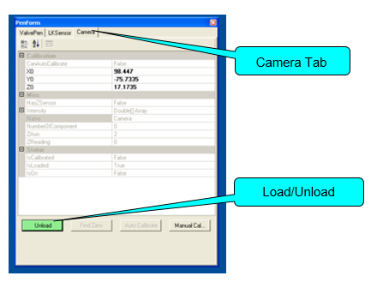

Switch the Upper monitor to the Camera view using the AV button on the remote
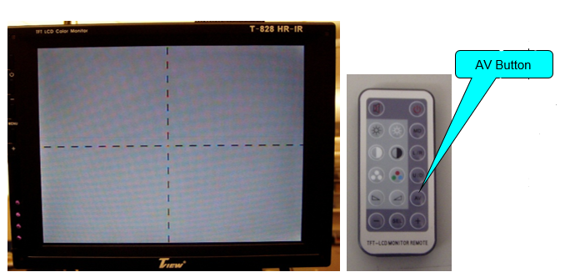
Focus the Camera using the Z control (value should be ≈17.5 mm)
Using the X,Y,Z tabs on the Control window move the Camera until it is directly over the scribed cross on the vacuum chuck

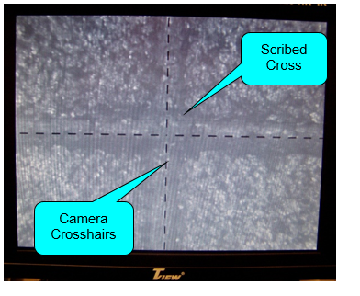

Click the Manual Calibrate button on the PenForm window
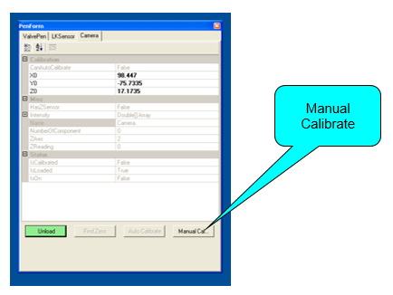

Valve Pen, Laser, Camera are now zeroed.

 | Potential Hazards | EC, Haz. Mitigation Device, PPE
- Pump Closed/Open positioning | Chemical | Machine Shielding

Using the axis controls in the Control window move the pen tip to center of the chuck. Place small catch basin under pen tip.
Click the Valvepen tab on the PenForm window. Click the Load button on the PenForm window. (button will be green when the device is loaded)
Switch the upper monitor back to the tip view using the AV button on the remote.

Click the Pressure tab on the Control window. Set the pressure between 5 and 15 PSI depending on the ink/paste viscosity. Lower viscosity=lower pressure.
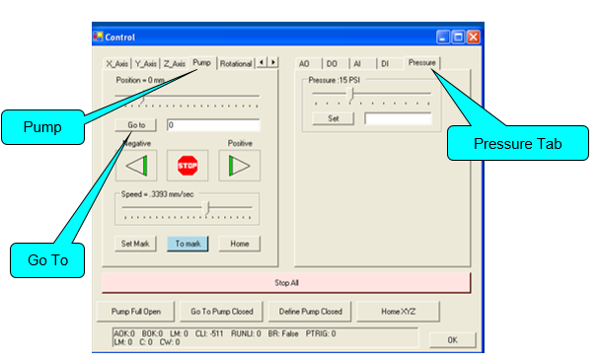

Select the Pump tab on the Control window
With the speed set to ~.2mm/sec. Enter 4 into the Go to box and press Go to.
While watching the upper monitor with the tip displayed) once you see paste being dispensed press the stop button. Make note of the valve position. (If valve gets all the way to 4 and no paste is flowing press the Go To Pump Closed Tab. Increase the pressure ~5psi and repeat the steps.)
Once paste is flowing click the negative button until paste stops flowing. Make note of this position.
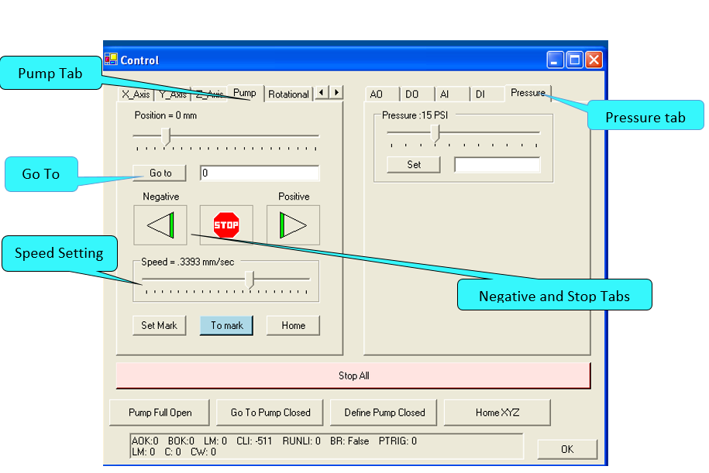

Click the Define Pump Closed tab on the Control window
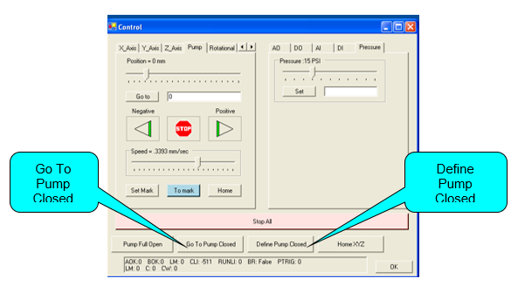
With paste not flowing enter the position, which you recorded earlier when paste was flowing into the go to box. Press Go To Tab. Looking at the upper monitor verify that paste is free flowing. If it is not then use the positive tab to open the valve until it is free flowing. Make note of the valve position. If paste is flowing quickly use the negative arrow to jog the pump closed a little bit until paste almost stops flowing. You are trying to find to position that paste just starts to free flow.
Press go to pump closed.
Enter in newly recorded valve position into the go to box and press go to. Verify if paste is free flowing. Repeat process if necessary. The delta between the open is usually less than .25
Once you have determined a position that paste is free flowing, press the go to pump closed button.
Make note of your pump closed position and the delta to the pump open position. You will need it when exporting you pattern.

 | Potential Hazards | EC, Haz. Mitigation Device, PPE
- Creating Script with Path2D |  | Machine Shielding

The Path2d program can be used to draw simple structures but you will be better off if you draw your pattern using a cad or solid works program. You will need to save your drawings as a DXF file for importing into the Path2D program.

For optimization of your lines and features it is recommended that you create a simple pattern of lines so you can test different parameters before moving on to your final print.

Open the Path2D program
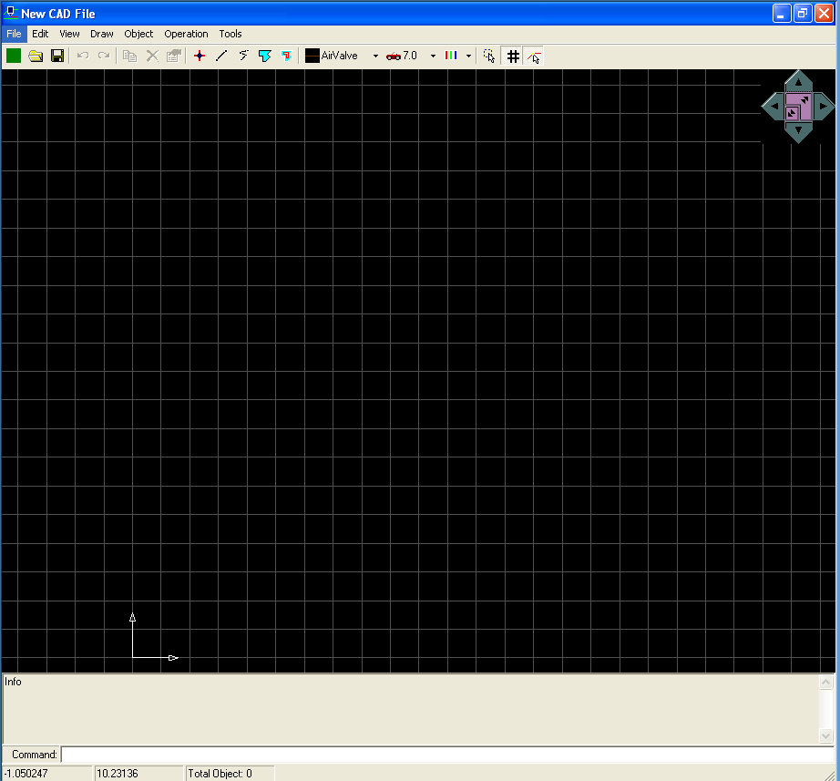

You can either draw your pattern or import a DXF from another drawing software.
If you are drawing a pattern start near the origin. You can change the speed of the printing of the line by changing the number next to the car icon in the tool bar. (You can also do this in the text editor after you have exported your pattern.)
After you have finished drawing skip to section about routine definition.

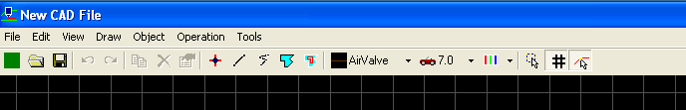

If you are importing a drawing click import from the file drop down menu and select DXF.

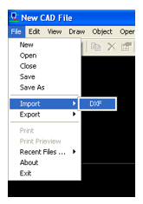
Click OK on the popup.
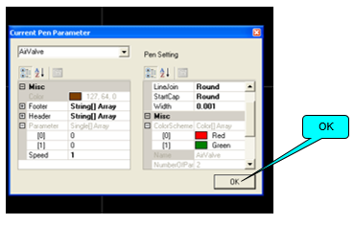
If your drawing was not imported at the origin you must move it to the origin
Click Select All from the Edit pull down menu
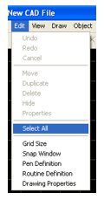
Click Move from the Edit pull down menu
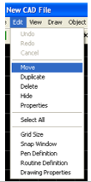
Click on the bottom left corner of the part then click on the origin in the Path2d grid.
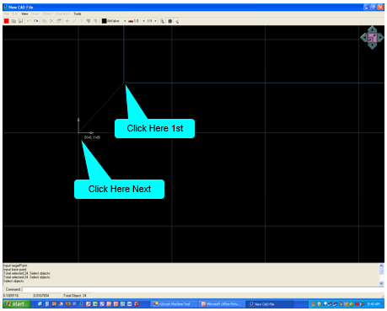

Better prints result from conditions lines rather that a bunch of short segments Remove all extraneous paths from file (i.e. all un-needed lines)
Click Select All from the Edit pull down menu
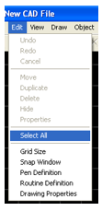
In the Operation pull down menu select Merge Touching Polylines, press Enter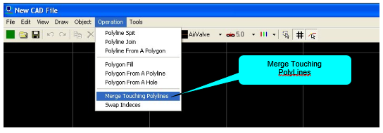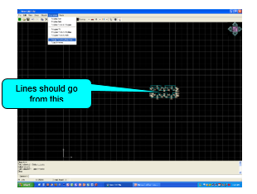 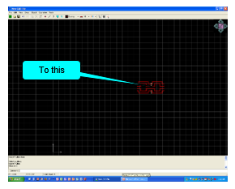

Routine Definition
From the Edit drop down menu select Routine Definition
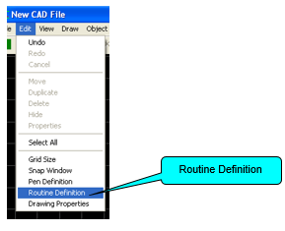
Expand Set Routine
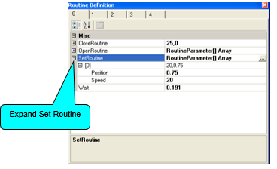
In the Position box enter in the value for the valve closed position. In the speed box enter 8. The speed parameter controls how fast the valve opens and closes it might need to be adjusted during the line tuning section, 8 is the manufacturer’s recommended starting point.
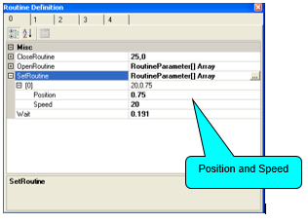
Expand the OpenRoutine. In the position box enter in the difference between the valve open position (paste free flowing) and the valve closed position. Usually values <.25. Enter 8 into the speed box. The speed parameter controls how fast the valve opens and closes it might need to be adjusted during the line tuning section, 8 is the manufacturer’s recommended starting point.
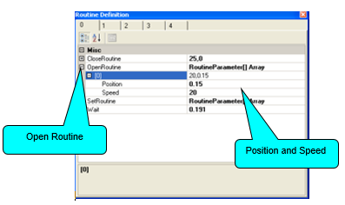

Expand the Close routine and enter in 8 for the speed and 0 for the position. The speed parameter controls how fast the valve opens and closes it might need to be adjusted during the line tuning section, 8 is the manufacturer’s recommended starting point.

Set the WaitTime to 0. The Wait time is the time from when the valve opens until the stage starts moving. Manufacture recommends 0 to start with but this is another parameter that might need adjusting during the line tuning.
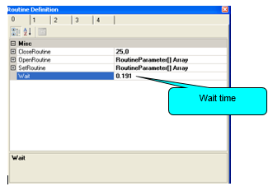
Close the Routine Definition window.
From the File drop down menu select export then Path File.
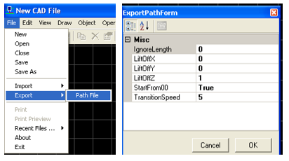
Set the StartFrom00 to True and the transition speed to 5.
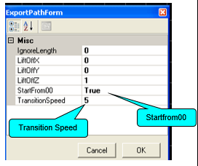

Click OK and save your file in the documents folder or on a flash drive.

You have now created a path file that the Nscrypt software will use when printing a script.
You need to open your .prg file in WordPad and remove some commands that are erroneously created(manufactured hasn’t/won’t fix) Please remove all the lines with “Start 3 8” and the lines “Stop 3” failing to do so will result in erratic valve opening and closing. After removing the erroneous lines of code resave your file.
This also where you can change the printing speed for each line. You will need to enter “Speed xx” above each line if you want it to print at a different speed.

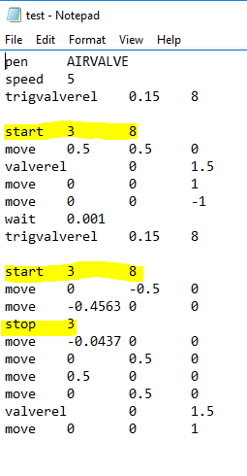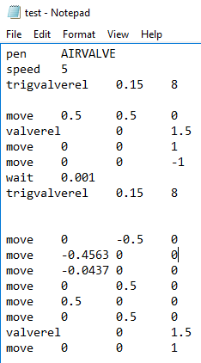

 | Potential Hazards | EC, Haz. Mitigation Device, PPE
- Running a Script for a stand-alone structure on a 2d substrate. | Chemical/ Mechanical | Machine Shielding

If you are printing on a 3d substrate or if you are printing a pattern that is making connections to already printed structures see advanced operations instructions in manual.

Switch Upper monitor to the Pen Tip view using the AV button on the remote
In the upper left-hand corner of the Nscrypt main page click the open folder icon and browse to find your script. Open it.
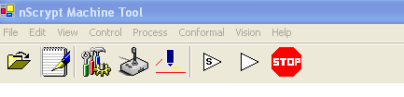
Click ok for the default pen is valve pen popup.
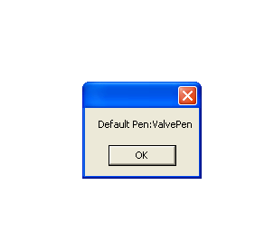
Your pattern should show up on the screen. You can rotate your pattern by right clicking and moving the mouse.
Run a simulation by clicking the white triangle with a “s” in the tool bar in the main screen. A simulation of your pattern should start to draw on the screen. Verify that sequence of lines seems logical.
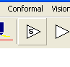
Using the axis control tabs in the resource control menu move the stage so the tip is over where you would like to start printing your pattern. Move the z axis down (When tip gets close to stage lower speed to ~.2mm/sec) until you have 200-500um clearance above your substrate. This clearance will need to be optimized depending on material.

Click on the white triangle to bring up the run menu
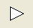
In the run menu screen set the dry run to true.
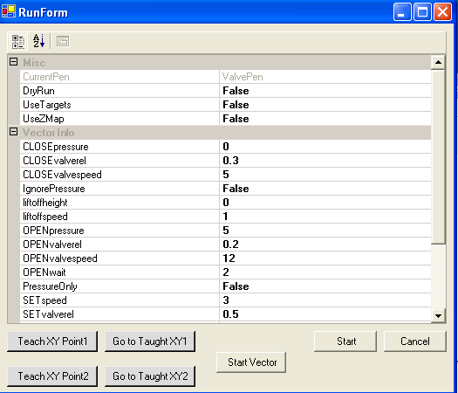
Click start in the run menu. After the buffer is loaded with your pattern, the print head should start moving mimicking the movements of your pattern but no ink will be dispensed.
If everything with the dry one seemed ok set DryRun to false.
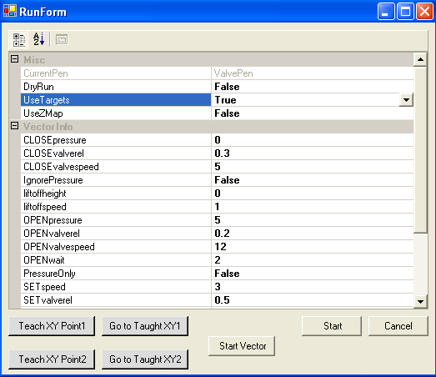
Use the resource control tab to purge a small amount of paste out of the tip. Position tip over a catch basin. Or on an area of your substrate that you can throw away.
Using the pressure tab in the resource control menu set the same pressure you were using when you determined the valve open and closed position.
Open the valve to same position that you are using as your valve open position. After a small amount of paste has been purged. Close the valve.
Using the axis control tabs in the resource control menu reposition the tip over your desired starting position with a clearance of ~200-500um
Click start in the run menu the motion of the stage should mimic the dry run motion but paste should be flowing during this print.
Close the run menu.
After the print is complete examine your structure most likely tuning/optimization will need to take place.

You can either edit your path2d file and export it again or you can use the Edit form icon(paper with pen) on the nscrypt main page. Typical parameters to edit is the speed for the lines and the z liftoff.
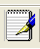
The edit form will open a text file. Make sure you understand each parameter that you are changing.
Save the text file. Once you close it the changes will be loaded into the nscrypt software.

For parameters not set by the script (pressure, z height) you can simple edit those on the resource control page, reposition the tip at your desired starting point and then open the run menu again and rerun your script.

Make adjusts until you are satisfied with you print. Print final pattern.

 | Potential Hazards | EC, Haz. Mitigation Device, PPE
- Cleanup | Chemical/Mechanical | PPE lab coat, gloves, safety glasses  Machine Shielding/Interlocks

In the resource control page jog the Z axis up to allow for clearance and removal of the print head.
Place a catch basin under the tip.
Set the pressure to zero
Open the valve all the way to 4mm to relieve any remaining pressure and to put it in position for valve rod removal.
Once paste is no longer coming out of the tip close the valve.
Obtain a couple wipes to place the dirty parts on.
Remove the Yellow pressure adaptor from the paste syringe
Remove the paste syringe and place a cap on the tip. If the luer came out of the valve body with the syringe remove it before placing a cap on your syringe.

Remove the tip retaining ring and tip. Place on wipe.
Remove Delran ring and valve body. Place on wipe
Wipe valve rod of remaining paste.
Remove valve rod by loosening set screw on right side 1/4-1/2 turn. Loosen set screw facing you 2 turns or until you can remove the valve rod with little force. Do not fully remove the set screws. Place on wipe
Use an appropriate solvent and wipe to wipe off any paste that may have gotten on the dry pump or stage.
Transfer dirty parts to ventilation hood. Clean dirty parts in an appropriate solvent Be careful to not damage tip as it is ceramic and fairly brittle. Sonication maybe needed. Return them to the printer when clean. Place tip back in the storage case.
