 |  | IML Annual Newsletter
January 6, 2016 | Volume 1, Number 1
“  NEW TO iLABS?  With many of the new BSU recharge centers joining the ranks of the iLABS community, there are plenty of resources to leverage from for help! Contact Diane Smith at NEW TO iLABS?  With many of the new BSU recharge centers joining the ranks of the iLABS community, there are plenty of resources to leverage fromfor help! Contact Diane Smith at dianesmith1@boisestat.edu to have all your questions answered.  dianesmith1@boisestat.edu to have all your questions answered.  EQUIPMENT TRAINING  Equipment training for individuals will start back up soon. Please contact Pete if you have already started and are in need of more training to complete certification or need a refresher. |  | 2015 Proves to be a year of out with the old and in with the new.  2015 Was definitely “In like a Lion and out like a Lamb!” What started out as a relatively quiet entrance into 2015, quickly transformed into a steady stream of lab preparations needed for upcoming improvements and additions to the lab.  HERC Grant Brings in New Equipment/Capability into the IML  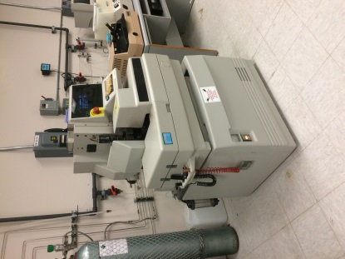  First, it was an “all hands on deck” to decommission and remove the old Micron donated CMP machine to make room for newly acquired wafer dicing machine. Other additions included a semi-automatic wire bonding machine and a gently used proximity alignment system to further enhance the patterning capability of the IML photolithography process. The new equipment purchased with the Higher Education Research Council (HERC) grant will provide enhancements to the areas of wafer dicing and device scalability for future projects.  New DI Water System will bring PURE Satisfaction to IML Users (no pun intended)  The newly installed DI water system, which had been in the planning stages for over a year, is now installed and operational. The system provides ultra clean (~18Mohm) de-ionized (DI) water to research labs located in the MEC and ET buildings, more specifically the cleanroom. Fitted with the latest technology in ultra-violet lamp disinfection and ultra-pure filtration tanks, it is sure to bring years of uninterrupted service to end users requiring ultra-pure DI water of the highest quality in their research.  ADT Wafer Dicing Saw  IML Joins the BSU iLABS Community  After months of preparations and training sessions, the IML went “live” with iLABS at the end of November. With the exception of only minor hick-ups, the transition into iLABS was relatively uneventful. The introduction to iLABS will allow better tracking of equipment use along with providing easier billing and reporting functions which will ultimately improve the efficiency of business related operations within the IML. Added features in the future may include automatic equipment interlocks for enhanced machine control and tracking.  IGEM Grant to Bring Much Awaited Equipment Upgrades and Additions to the IML.  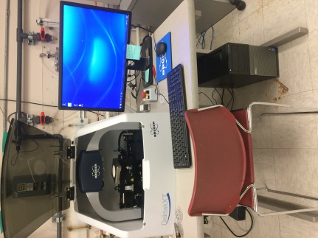  The recently funded Idaho Global Entrepreneurial Mission (IGEM) grant to the IML is slotted to be the largest financial boost to the lab since the conception of the BSU ECE PhD program. The $1.5M grant will help with facility upgrades, new equipment purchases and the addition of a cleanroom lab technician along with system upgrades to existing equipment. The three-year grant will provide funding for the much needed facility upgrades which have hindered the addition of advanced semiconductor processing equipment. Three new wet benches along with a new stylus profiler and other peripheral equipment are not part of the arsenal available for use by IML user.  IML to Partner with KNOWN on joint venture of memristor fabrication  The IML and KNOWN.ORG are currently in the process of developing a partnership that will allow the IML to become a forefront runner in memristor fabrication with its unique fabrication methods. KNOWM, a company that has licensed the BSU memristor technology developed by Dr. Kris Campbell, is already in the process of sending samples of fabricated chips into the IC design industry and has been well received by the circuit design community. The IML is excited to help KNOWM “incubate” the licensed technology with hopes of eventually expanding into their own facility. Preliminary fabrication will be done in the IML cleanroom and processing lab utilizing many of the added capabilities and features recently put into place. Potential new business partnerships could spawn as a result of the impending partnership and couldn’t have come at a better time. To read more about KNOWM go to www.knowm.org.  Bruker Stylus Profiler  2016 Shaping up to be a busy year in the IML.  With the IGEM grant execution heading into its first year, there is a lot of work to be done to keep pace with the deadlines. Lab shutdowns are inevitable with the changes scheduled to happen and IML leaders and support staff are doing their best to keep the disruptions to a minimum. Here is a list of the MAJOR items currently scheduled to be completed by the end of 2016 with their expected shutdown dates and length of time.  - March 7-11; wet benches install (estimate only)  - May 10-19; IML HVAC air handler upgrade (part of building upgrade.)  As always, the dates can be pulled in or extended out based on scheduling conflicts and we do our best to keep everyone involved informed.  As part of the IGEMs grant, two new positions, cleanroom tech and ECE research faculty, have been approved and will be filled early 2016.  Thank you to those of you who helped make 2015 another exciting year in the Idaho Microfabrication Laboratory and I hope to see more of you in 2016 utilizing the newly acquired resources in the lab.  Cheers and GO BRONCOS!  Pete Miranda  Contact Info:  Pete Miranda  Director  Idaho Microfabrication Lab  Boise State University  1910 University Dr.  Boise, ID 83725  Ph:208-426-5713  Email: pmiranda@boisestate.edu
Thank you to the following sponsors for their support in making the IGEM grant a success.


