|  |
| --- |
| Boise State University |
| IDAHO MICROFABRICATION LABORATORY |
| Standard Operating & Safety Procedures |

|  |
| --- |
| written by Peter Miranda  3/1/2016 |

Date Revision Description Author

|  |  |  |  |
| --- | --- | --- | --- |
| **3/2013** | **A** | **New** | **P. Miranda** |
| **3/2016** | **B** | **Reformatted; general changes** | **P. Miranda** |
|  |  |  |  |
|  |  |  |  |

**Table of Contents**

**1.0 GENERAL INFO 3**

1.1 IML Background 3

1.2 Hours of Operation 3

1.3 Buddy Rule 3

**2.0 IML MANAGEMENT STRUCTURE 4**

2.1 Roles & Responsibilities 4

IML Committee 4

IML Director 4

IML Team 4

IML Users 4

**3.0 IML GENERAL SAFETY AND EMERGENCY RESPONSE PLAN 5**

3.1 IML Safety Policy 5

3.2 General Safety Guidelines 5

3.3 General Emergency Procedures 5

3.4 Emergency Response Contacts 6

Primary Response 6

Secondary Contacts 6

3.5 CPR Response 7

3.6 Use of the Automated External Defibrillator (AED) 7

3.7 Emergency Response Plan 7

3.7.1 Fire/Earthquake 7

3.7.2 Power Failure 8

3.7.3 Chemical Spill 8

**4.0 GENERAL IML USER RULES AND RESTRICTIONS 9**

4.1 Authorized Users of the IML 9

4.2 User Rules and Restrictions 9

**5.0 IML CHEMICAL SAFETY 10**

5.1 General Chemical Safety 10

5.2 Specific Chemical Characteristics 11

5.2.1 Typical Acids used in the IML 11

5.2.2 Typical Bases used in the IML 11

5.2.3 Typical Solvents used in the IML 12

5.3 Chemical Waste Disposal 12

5.3.1 Disposal of Acid & Base Waste 12

5.3.2 Disposal of Solvent Waste 12

5.4 IML Solid Waste Disposal 13

5.5 Accidental Chemical Spill Containment and Response Plan 13

5.5.1 Identification of potential spill/discharge sites and pathways 13

5.5.2 Spill and Leak Prevention 13

5.6 IML Automated Chemical Neutralization System 14

5.7.1 Wastewater Management for ET107 15

5.7.2 Wastewater Management for ET105 15

**6.0 IML COMPRESSED GAS SAFETY 15**

6.1 General Compressed Gas Safety Procedures 15

6.2 Liquid Nitrogen Handling Safety 16

6.2.1 Specific Hazards 16

6.2.2 Storage 17

6.2.3 Authorized personnel 17

6.2.4 Training Requirements 17

6.2.5 Transferring and transporting liquid nitrogen 17

6.2.6 Dispensing liquid nitrogen from large storage tanks 18

6.2.7 Transporting liquid nitrogen between buildings 18

6.2.8 Transporting liquid nitrogen within laboratories and between laboratories in the same building 18

6.2.9 Decontamination 18

6.2.10 Spills or Leaks 18

6.3 Use of Liquid Nitrogen as a Coolant in Electron Microscopes and Other Instrumentation 18

**Appendix A. Idaho Microfabrication Laboratory Layout. 20**

**ET107 20**

**ET105 20**

**Appendix B: IML Evacuation Plan. 21**

**Appendix C. IML Student Users Agreement. 22**

**Appendix D. Common Chemicals Used in the IML. 23**

**Appendix E. Chemical Spill Investigation Report 24**

# 1.0 GENERAL INFO

## 1.1 IML Background

The Idaho Microfabrication Laboratory (IML) was completed in the Fall of 1998 as part of the overall plan put into place by the Boise State University College of Engineering to provide a “hands-on” laboratory experience for students studying microelectronics. It is located on the Engineering and Technology Building in the South part of the building on the first floor (ET107). The IML consists of a gowning room, a 900 ft2 Class 1000 cleanroom, a 1500 ft2 process lab, a 900 ft2 metrology lab and a 400 ft2 mechanical support room. Shown in Appendix A, is the layout of the lab and the placement of processing tools. The lab is equipped to support basic integrated circuit processing (IC) steps using the equipment set listed below:

* diffusion and oxidation tunnel furnaces
* photoresist spin-coating and development
* proximity/contact alignment tool
* magnetron sputtering system
* ellipsometry
* film thickness characterization
* chemical wet processing stations
* plasma asher

In addition, the IML utilities include temperature-controlled-HEPA-filtered air, process exhaust, compressed clean dry air (CDA), process vacuum, process cooling water, de-ionized water, 120V/208V 3-phase power and wastewater pH neutralization treatment system. Oxygen, Argon, Nitrogen and other process gases are also connected to tools in a point of use arrangement. Located adjacent to the IML cleanroom are two other labs used in conjunction with the IML. On the east side of the IML is the IC processing lab (ET105), which is associated with the IML, housing other processing equipment used in IC fabrication that are listed below:

* CHA Thermal Evaporator
* Oxford Bosch Etcher
* Rapid Thermal Annealer
* Veeco Ion Mill
* AJA Sputtering System

The scope of this document will cover laboratory operations involving the use of both labs to perform the fabrication of integrated circuits and microelectronics.

## 1.2 Hours of Operation

Normal business hours – 7am to 6pm (Mon through Friday)

Weekends hours vary and are dependent on the type of work being done – there is limited to no support on the weekends in the IML.

Closed for Major Holidays: Thanksgiving, Xmas, New Years

## 1.3 Buddy Rule

The IML is open 24 hours a day, 7 days a week (excluding major holidays). The IML “buddy” policy is designed to provide a safety program to protect you in the event of an IML incident involving electrical, mechanical or chemical harm. Depending on the specific task you are performing inside the IML, your buddy may or may not be required to be within close proximity of you. Your “buddy” is someone who can get you to an eye wash station should you splash chemicals in your eyes; they are the ones who can keep others away from a harsh environment you may have accidently created while you seek assistance; they are the ones who can assist you in the event of electrical shock or burn incident.

Your buddy must be one who has attended the IML safety class and has general knowledge of what you are doing.

1. You must have a “buddy” inside the IML with you if:
   * You are inside the lab from 6pm to 7am M-F or on the weekends (6pm Friday to 7am Monday) operating any piece of equipment other than a microscope.
   * You are working in the IML during normal lab access hours (7am to 6pm M-F) involving the following processes:
     + HF and BOE chemistries
     + Hot piranha chemistries
     + Metal etch (Cr, Al, Au, Ti) chemistries
     + Silicon etch (KOH, TMAH, EDP) chemistries
     + high voltage equipment usage (including SEM filament changes)
2. You must have a “buddy” check on you every 30 minutes (within-building phone checks permitted) or is in close proximity (but not necessarily inside the IML with you) if:
   * You are working with a PVD system (sputter, thermal evap, etc.)
   * You are working with dry etching equipment
   * You are working with photolithography processes
   * You are working with high temp furnaces or ovens
   * You are working on the SEM from 9pm to 6am.
3. You are exempt from the “buddy” rule if:
   * You are using a microscope at any time.

# 2.0 IML MANAGEMENT STRUCTURE

## 2.1 Roles & Responsibilities

### IML Committee

The IML Committee is responsible for the overall operation of the facility such as monitoring utilization, determining access, establishing priorities and policies, approving user fees, and planning upgrades of the infrastructure.

### IML Director

The IML Director is responsible for the day-to-day operation of the facility in addition to the implementation and the enforcement of the regulations and procedures. The various procedures themselves are determined by the IML committee in close coordination with the IML Director and IML team. As mandated by the IML Committee, the IML Director is responsible for training, granting access to the IML, supervision of personnel, operation and maintenance of equipment, safety, health, billing, and updating usage statistics necessary for reporting and for future upgrades.

### IML Team

The IML Team is comprised of the IML Director, one engineering technician and one or two IML student assistants. The team is responsible for all equipment installations, repairs and maintenance. In addition, the team instructs and guides users in the use and operation of the process equipment under their collective responsibility. All members of the team must ensure that users operate machinery as instructed, and have the authority to restrict access should a user fail to do so.

### IML Users

IML users include faculty, postdocs, graduate and undergraduate engineering students as well as other users from both within and outside the university. Users must comply with the ensemble of regulations and procedures detailed in this and other IML documents related to their specific task.

# 3.0 IML GENERAL SAFETY AND EMERGENCY RESPONSE PLAN

## 3.1 IML Safety Policy

The Staff and Management of Boise State University’s Idaho Microfabrication Lab have implemented reasonable measures to ensure that the facility provides a safe and clean working environment for everyone accessing the facility. It is the responsibility of all users, visitors and staff to act in a professional, courteous and safe manner at all times while in the facility. Violating the regulations or procedures detailed in this document, or endangering the safety of yourself or others, will result in the immediate denial of access to the facility.

This portion of the manual is an integral part of the safety training program for students, faculty, staff, and emergency response personnel who work in and/or are responsible for the IML. All users of this facility are required to participate in a safety training program prior to using the laboratory. This safety program consists of:

1. Classroom or one on one instruction to review the contents of this document.
2. Tour of the lab, highlighting fire alarm locations, emergency exits, use of emergency eyewash/shower, emergency telephone procedures, and chemical spill clean-up procedures.

The items listed above are routinely covered during the first 3 hour lab session of every course taught in the IML, as well as with each new faculty/staff member who requests access to the lab. A master list of persons who have passed this training and are qualified to work in the lab is maintained by the IML Director, and a users agreement form (Appendix C) must be signed by both the IML Director and the qualified user.

## 3.2 General Safety Guidelines

All persons using the IML will be instructed in emergency procedures, safety precautions, hazardous material handling and disposal procedures, and specific hazards related to the facility, equipment, and operations.

* Safety glasses are required when operating applicable machinery in the lab.
* All persons using the IML will be required to read and complete the safety program.
* You must follow the buddy system outlined in Section 1.3 at all times.
* The best safety precaution is to understand exactly what you are doing and what the potential dangers are AT ALL TIMES. If you do not understand something or have questions, do not be embarrassed to STOP AND ASK before attempting to perform a task.
* Appropriate personal protective equipment (PPE) is required when working with chemicals and certain pieces of equipment. This includes full rubber acid aprons, rubber gloves, and face masks when pouring or diluting acids and/or bases.

## 3.3 General Emergency Procedures

If the fire alarm sounds, everyone must leave the IML immediately and associated lab through either one of the emergency exit doors on the front (north) wall of the room and exit the building through either the east or west exit doors. All persons in the mechanical room are to exit through the back (south) doors. Campus safety will meet with faculty, staff, and the emergency response team at the southwest entrance of the building (Manitou Street).

**ET107 Fire alarm pull boxes are located:**

1. **in the mechanical room next to the south exit doors**
2. **at both the east and west building exit doors.**

In the event of a fire in the IML, everyone must exit the IML immediately, and pull the alarm boxes as they exit the building. If you are working in ET107 or ET105 and should any part of your body be accidentally exposed to a chemical, immediately proceed to the emergency eyewash/shower located on the south wall and activate by hand or foot. Thoroughly flush eyes and/or skin with water for at least 15 minutes. The first aid kit, emergency telephone, and fire extinguisher are also located on the south wall of the lab next to the double doors. **Call 911 and request emergency personnel to come to the IML in the Engineering & Technology Bldg. at 1375 University Drive.**

**ET105 is equipped with a eye wash station located in the southwest corner of the lab.**

## 

## 3.4 Emergency Response Contacts

For hazardous chemical spills, call 911 first and then the response team, and tell them exactly what happened and who requires treatment. If the spill is from a known chemical, be sure to tell the emergency team (along with the MSDS sheet from the lab) if possible. If the chemical is unknown, tell the 911 team that you do not know what the chemical is.

Be available at the southwest building entrance (Manitou Street) to meet with the emergency contact someone from the emergency response contact list in section 3.4.

### Primary Response

If you are at risk, evacuate the laboratory and DIAL 911 from any telephone. Identify yourself, the location and type of incident and if an evacuation is underway.

**IML Physical Address:**

Engineering and Technology Building, Room 105/107

1375 University Dr.

If other occupants of the building are at risk, pull the fire alarm on your way out. Do not attempt to neutralize an IML incident including clean-up of unknown chemicals.

Your responsibility is to call 911 and notify the appropriate staff or personnel.

### Secondary Contacts

**IML Staff Contacts:**

IML Director, Peter Miranda

Office Telephone: 426-5713

Cell Phone: 891-5997

Assistant Dean of Research and Infrastructure, Rex Oxford

Office Telephone: 426-5744

**University Contacts:**

University Security (non-emergency, 24-hr line) 426-1453

Fire Department (non-emergency) 377-7351

**Environmental Health and Safety Office**

Barbara Beagles, 426-3343

Chris Siepert, 426-3913

Randy Bunnis, 426-1482

EH&S Cell Phone, 863-8024

## 3.5 CPR Response

* If a person is unconscious, first call 911.
* If you are trained in CPR, call 911, then administer CPR.
* If you are not trained in CPR, call 911, and find someone who is.

Information on CPR-trained COEN personnel will be posted on the entrance to the IML should you not find CPR-trained personnel nearby.

## 3.6 Use of the Automated External Defibrillator (AED)

**Use of Defibrillator:**

* If a person has suffered a cardiac incident, call 911 and then use the Automated External Defibrillator (AED).
* Automated External Defibrillators (AEDs) are intended to manage sudden cardiac arrest in workplace settings.
* For greatest benefit, the AED should be used as soon as possible on the victim.

**Defibrillator Location**

* The closest defibrillator to the IML is located in MEC, 2nd floor at the end of the breezeway on the wall opposite the elevator.
* Bring the defibrillator to the location of the victim.
* Manufacturers’ recommendations state that the AED should be used by trained personnel only.
* An untrained individual who uses an AED would be protected within the legal limits of the Idaho Good Samaritan Act.
* The AED is equipped with written, pictogram and voice prompts instructions on proper usage.

**Poison Control**

Emergency 911

Non-emergency 800-860-0620

**MSDS & Toxicology Data**

<http://www.hazard.com/msds/>

## 3.7 Emergency Response Plan

Each type of emergency requires a different type of response. The CORRECT response will create a safe situation for all building occupants and will minimize damage to the lab and its equipment, and disruption to the building occupants. The IML Director should be called immediately after any emergency response has been initiated. The main types of emergencies are: fire, earthquake, chemical spill, and power failure.

### 3.7.1 Fire/Earthquake

Evacuation of all IML and building occupants is required in case of smoke, fire, or earthquake. Evacuation routes are posted on the lab door for you to reference (see Appendix B). DO NOT ATTEMPT TO FIGHT A CHEMICAL FIRE SINCE YOU MAY PUT YOURSELF AND OTHERS IN GRAVE DANGER. The evacuation routes are through either of the IMLs front (north) doors and through the hallway to either the southeast or southwest building exit doors. The fire alarms located next to these building exits should be pulled if necessary. These alarms will alert both campus and city fire response teams. All emergency personnel should meet at the southwest entrance to the building (Manitou Street).

Your Role in a Fire:

* Call 911
* Your safety and the safety of others should be your primary consideration in the event of a fire.
* You should not attempt to fight a large fire.
* You are not required to fight a small fire. However, at your discretion, you may extinguish a small fire.
* Report all fires of any size, after extinguished, to a laboratory contact person and a member of the EH&S staff.

### 3.7.2 Power Failure

In the event of a building power failure, the emergency lights and fume exhaust system will be powered by the building's backup generator. All lab users can remain next to their stations in the lab unless the power outage persists, in which case they should exit the lab through the gowning room in the usual fashion.

### 3.7.3 Chemical Spill

When possible, only one container of any given chemical should be in use outside the chemical storage cabinet at any time. This policy limits the quantity of chemical that could be spilled. However, should a serious chemical spill occur in which 1) the lab exhaust system is unable to remove the fumes from the IML or 2) the chemical is flammable or 3) the capabilities of the spill clean-up kit are exceeded, then evacuation of all IML and building occupants is required. Each exit from the lab is equipped with an in-floor spill trap which will catch and hold spills of several gallons inside the room for later clean-up. The evacuation routes are through either of the IMLs front (north) doors and through the hallway to either the southeast or southwest building exit doors. The fire alarms located next to these building exits should be pulled. These alarms will alert both campus and city fire response teams. All emergency personnel should meet at the southwest entrance to the building (Manitou Street). Small spills of nonflammable chemicals should not require evacuation of the building, unless excessive fumes are generated. The spilled chemical can be contained by using one or more spill pillows (non-reactive, clean, absorbent material) available in the spill clean-up kit next to the chemical storage cabinet on the back wall of the lab. Cleanup will be done by trained faculty or staff. A drum is available on the back loading dock for disposal of the used spill pillows.

If a chemical accidentally comes in contact with the skin or eyes of a lab user, immediately proceed to the emergency eyewash/shower on the back wall of the lab, and activate by hand or foot. Thoroughly flush the affected areas with water for at least ten minutes. The first aid kit, emergency telephone, and fire extinguisher are also located on the back wall of the lab next to the double doors. Other lab users must assist the affected user by determining the exact name of the chemical, pulling the appropriate MSDS sheet from its location near the phone, and initiating the specified first aid treatment. If serious, call 911 and request emergency personnel to come to the BSU IML Lab at University Drive & Manitou Street. For hazardous chemical spills, also call 426-1409 or 426-3200. Report the nature of the emergency and exact name of the chemical(s) involved. Be available at the southwest building entrance (Manitou Street) to meet with the emergency response team, and tell them exactly WHAT happened, WHERE it happened, and WHO requires treatment. Write the chemical name and symbol on a sheet of paper and give to the emergency team (along with the MSDS sheet from the lab). Following this response, an accident report must be filed by all lab users involved.

# 4.0 GENERAL IML USER RULES AND RESTRICTIONS

## 4.1 Authorized Users of the IML

IML use is limited to specially trained engineers, technicians, research associates, and graduate students as well as associated faculty members & scientists. Students enrolled in a class associated with the IML are permitted access during laboratory hours and only under the supervision of the lab instructor. All IML users are required to complete the following steps before they are allowed access to the IML. The procedure is as follows:

1. Fill out the IML Student User Agreement and read the User Rules and Restrictions for the IML.
2. Attend a IML orientation session. (This will be your first lab in the IML if you are taking a class).
3. Receive email notification of final approval from the IML Director.

## 4.2 User Rules and Restrictions

The following rules are to be observed by all persons qualified to work in the Microfabrication Laboratory:

1. Safety glasses are to be worn as required while in the IML labs.
2. Only individuals qualified to work in the IML are those who have satisfied all conditions in the “authorized users” section.
3. NO makeup shall be worn inside the IML.
4. Food and drinks are prohibited in the IML.
5. Smoking is not allowed 30 minutes before entering the IML.
6. Chewing gum is not allowed in the IML.
7. Avoid wearing contacts. Contacts can absorb vapors or trap chemicals in the space between the lens and the eye. In an emergency eye muscles may spasm, preventing removal of the contact lens. Contacts may thus interfere with flushing the eye with water and allow the eyes long and intimate contact with toxic chemicals. If you take your contacts before you enter, don't bring them into the lab and store them near volatile chemicals. Leave them in a safe place outside of the lab.
8. Check your clothing. Everyone must wear full-length pants when using the lab. You may put on a pair of pants over shorts. Avoid gowning over bare legs. Do not enter wearing sandals or open-toed shoes. Do not wear muddy shoes. If you step in a mud puddle on the way to the IML, cover your shoes with the blue “booties” that are provided.
9. Only use pens and IML paper. Lead pencils are not allowed in the cleanroom.
10. Bunny suits, booties, mustache/beard nets, and gloves must be worn at ALL times in the IML.
11. Your name MUST appear on the QUALIFIED USER LIST to operate ANY piece of equipment in the IML.
12. Nonessential items of equipment (tools, books, etc.) will not be allowed to accumulate and will be removed from the lab at the discretion of the IML Director.
13. Try not to sneeze or cough in the IML. Don't breathe directly on a clean surface or wafer.
14. Singing, and whistling also produce severe contamination. Do not let your skin touch any

surface in the IML. In particular, don't touch your face and then a lab surface. Your skin will leave behind oils. If you believe something has been contaminated, clean it.

1. Once inside the IML, there are a few precautions you can take to maintain IML integrity. Do not enter the HVAC chase area. Be aware if you tear any part of your bunny suit or booties. Move slowly and carefully to minimize air turbulence. Don't slam any of the doors; this also creates turbulence and shakes the partitions, resulting in additional contamination.
2. Always clean up your work area before you leave. Thoroughly rinse the beakers you used with DI water and then store upside-down in their appropriate locations.

# 5.0 IML CHEMICAL SAFETY

## 5.1 General Chemical Safety

The following safety rules are to be observed by all persons qualified to work in the IML. The chemicals used in the IML are extremely hazardous. Appendix B lists common chemicals used in the lab and their concentrations. These concentrations, necessary for microfabrication, are much higher than those found in conventional undergraduate chemistry labs. Many of these chemicals can cause severe damage to human tissue. Therefore, you must be alert and cautious when using these chemicals to avoid all contact with them. When you follow the safety procedures below, your risk of injury will be minimized.

* **ALWAYS FOLLOW THE BUDDY RULE WHEN WORKING ON THE WET BENCH.**
* DO NOT use a chemical in the IML without first reading its MSDS.
* Know which chemicals and containers are compatible. Some chemicals, such as TCE, cannot be used with plastic beakers. Some chemicals, such as HF, cannot be used with glass beakers.
* Always work with chemicals under the appropriate fume hood. Heavy-duty rubber gloves, a chemical apron, and a face mask must be worn when handling hazardous chemicals in the IML.
* When mixing chemicals, use only one bottle at a time. Do not open a new bottle unless an existing bottle is completely empty. Pour the chemical slowly. Do not let it gulp. Remember the Triple A Rule: "Always Add Acid to water," never the reverse. This prevents violent splashing.
* Only mix chemicals from established procedures or carefully researched extrapolations.
* Don't pour chemicals back into the storage bottle. If you pour out too much, dispose of it appropriately.
* Put the cap back on each chemical bottle securely and use a damp cloth to wipe any spillage on the outside of the container. Dispose of the wipe in the appropriate waste bin.
* Do not leave your chemicals unattended. If the chemicals will be in use for several hours, arrange with the IML Director or lab technician to leave them. In addition, clearly mark the name of the chemicals, your name, where someone can contact you, and when you expect to return on a clean wipe. Leave this sign next to the chemicals.
* When using hot plates, check that your beaker is both suitable for hot plate use and smaller than the area of the plate.
* Never use a Teflon or plastic beaker on a hot plate. Always monitor the temperature of the chemicals on a hot plate with a Teflon coated thermometer.
* Rinse the heavy chemical gloves with DI water before you take them off.
* Always clean up your work area before you leave. Thoroughly rinse beakers you used with DI water and then store upside-down in their appropriate locations.
* There are three fire extinguishers available for small fire emergencies. One is located by the eyewash station on the south wall of the IML. One is located by the northwest entrance into ET105 and the other is located by the south doors to the mechanical room.
* Tell your supervisor about any unsafe situation. Use your judgment. For example, if a beaker of chemicals is sitting around without a label, report it.
* If you are not sure something is safe, ask your supervisor. Use common sense. There are no unexpected dangers in the IML, but do not touch anything unless you are sure you understand it.
* Aprons are available to protect your clothing. A drop of photoresist may splash onto clothing and make a permanent spot.
* Hydrofluoric acid (HF) is more dangerous than it seems. Because HF does not hurt when it makes contact with skin, people get careless. HF hurts badly when it makes contact with eyes, lips, fingernails, etc. The pain may not start for a few hours, but it may last for days. For HF burns, get medical help immediately.
* Wash your hands with soap and water when you leave the lab.

## 5.2 Specific Chemical Characteristics

**ACIDS**

* Are typically soluble in water.
* Are corrosive.
* Form salts when mixed with bases.
* Turn litmus paper red (pH<7). Litmus paper located above wet bench and inside toolbox.
* Burn organic tissues and/or inorganic materials.

### 5.2.1 Typical Acids used in the IML

* **Hydrochloric -** HCL
  + Highly corrosive to skin and mucous membranes. Repeated exposure causes erosion of teeth.
* **Hydrofluoric - HF**
  + Liquid and vapors cause burns that may not be immediately painful or visible. HF attacks glass. HF looks like water and can kill in small amounts. Found in Buffered Oxide Etch (BOE). Use only in plastic containers.
* **Nitric -** HNO3
  + Highly corrosive to skin, mucous membranes and teeth. Highly reactive with acetic acid. Reacts explosively with combustible organic or other oxidizers. Use only in glass containers.
* **Phosphoric -** H3PO4
  + formation of flammable and explosive hydrogen gas.
* **Sulfuric -** H2SO4
  + Liquid and vapors are extremely corrosive to skin and mucous membranes. Generates heat upon contact with water. Reacts with acetic acid. Keep away from water.

**BASES**

* Are typically water soluble.
* Are slippery.
* Form salts when mixed with acids.
* Turn litmus paper blue (pH>7).
* Are corrosive.
* Burn organic tissues.

### 5.2.2 Typical Bases used in the IML

* **Ammonium Hydroxide** - NH4OH
  + Irritating to skin and mucous membranes. Emits highly toxic vapors when heated.
* **Potassium Hydroxide** - KOH
* **Sodium Hydroxide** – NaOH
* **Photoresist developers**

**SOLVENTS**

* A solvent is a chemical substance which dissolves another substance. The most common solvent is water.
* Solvents are used extensively in the electronics industry. Compounds such as Isopropyl Alcohol (IPA) and acetone are used to clean and dry wafers, glassware, equipment, and most working surfaces in the lab. In addition, solvents are the principle components of many process chemicals such as photoresist.
* Organic solvents react chemically with acids, producing a violent reaction. As a by-product of the chemical reaction, gases are released, as well as a great amount of heat. Therefore, acids and solvents and their vapors should never come into contact with one another.
* Organic solvents should never come in contact with oxidizers such as hydrogen peroxide and chromic etch.

### 5.2.3 Typical Solvents used in the IML

* Acetone - ACE
* Isopropyl Alcohol - IPA
* Propylene Glycol Monomethyl Ether Acetate - PGMEA

## 5.3 Chemical Waste Disposal

### 5.3.1 Disposal of Acid & Base Waste

* Acids (including piranha) and Bases, must be aspirated from their containers. An aspirator has a Teflon® tube through which it sucks a liquid from a container. The IML wet sink has an aspirator. The fresh water **plenum** **flush** is automatically activated when an aspirator is turned on. The plenum flush adds water to aspirated waste, further diluting it. **NEVER POUR ACIDS, BASES directly down a drain: Always use the aspirator. Never mix solvents with acids when aspirating – This is a potentially explosive combination!** **And remember AAA-always add acid to water!**

### 5.3.2 Disposal of Solvent Waste

* Solvents are never to be aspirated or poured down the wet bench drain. Solvents must be poured into solvent disposal bottles which are empty solvent bottles that have been rinsed.
* **Never pour acid for disposal into a solvent waste bottle because an explosion may result.**
* Solvent waste containers are to be stored inside the solvent waste cabinet until they are full.
* Make sure chemical disposal bottles are not overfilled. When a solvent disposal bottle is approximately 75% full:
* Loosely cap the bottle. DO NOT TIGHTEN THE CAP. This prevents accidental pressure buildup from breaking the bottle.
* Never remove the label from the chemical disposal bottle always mark a line through the previous contents. Enter the summary of contents to the peel-off label and place on the bottle.
* Chemicals for disposal placed in the Solvent Waste Chemical Cabinet must be labeled with contents and the name of the lab member. Placing unlabeled chemicals for disposal in this cabinet is a violation of lab policy, which may result in suspension from the IML. You must fill out the Chemical Disposal Manifest Sheet located on top of the disposal cabinet. The bottles are picked up by the BSU Environment, Health and Safety Department. Notify the IML Director if the storage area is full.
* Use a safety carrier if the bottle is glass. Rinse bottles thoroughly 3 times under the fumehood. This will prevent exposure to volatile compounds while rinsing bottles. Wear a face shield and chemical resistant gloves while doing so. Once the bottle has been rinsed 3 times, black out the label with a marker. The scratched label indicates that the bottle has been properly rinsed and is ready to be picked up by Environmental Health & Safety Services. Small incidental quantities should be rinsed down the drain with copious amounts of water.

## 5.4 IML Solid Waste Disposal

**Disposal of scrapped silicon wafers (sharps)**

* Silicon wafers that have been identified as containing hazardous materials on them and are considered scrap by the end user are to be disposed of in the container marked “Hazardous Sharps”.
* All other wafer scrap can be placed in the municipal waste container.

**Disposal of rags/wipes saturated with solvent**

* Disposal of rags/wipes that have been saturated with copious amounts of liquid solvents should be left under the wet bench hood to allow evaporation prior to discarding in the waste container.

## 5.5 Accidental Chemical Spill Containment and Response Plan

For all chemical spill incidents inside ET105 or ET107, please refer to the **Accidental Spill Prevention, Initial Response and Reporting Plan (ASPP)**. A brief summary of the major sections included in the document are discussed in the following.

### 5.5.1 Identification of potential spill/discharge sites and pathways

The area with the highest potential for a spill is located in the south end of the IML. This area contains five storage cabinets. One contains the solvents. The other three contain the acids and bases. Within the cabinets, all chemicals are in sealed containers that are accurately labeled as to their contents. When possible, no more than one container of any hazardous substance should be outside of the cabinets at any time. Thus, a chemical spill anywhere should never be more than a couple gallons. Other potential spill areas are the transportation paths between storage and the chemical processing stations.

The Wet Sink also provides a potential for larger spills. Chemicals are transported by IML users to the place they are needed, and then returned immediately after use. Areas surrounding pumps, valves, and other flow regions are designed such that the potential for a spill is minimized. All of the waste plumbing in the IML was done with Fuseseal. This plumbing consists of piping that is hot-welded together and that can withstand high flows as well as corrosive fluids such as strong acids.

**Any spill that has came from the wet bench area should always be considered hazardous and handled and reported in accordance with the ASPP.**

### 5.5.2 Spill and Leak Prevention

The IML was constructed to be leak-proof. The only cracks to the outside are at the bottom of exit doors. However, at these sites there are ½” rubber lips around the crack to stop any liquid from seeping through. In front of the doors there are also drain-like traps on the floor. These traps, can store up to 20 gallons of liquid and should prevent a liquid spill from reaching the doors. If a chemical spill is caught in the traps, it should be cleaned just like a spill on the floor using the spill clean-up kit, and then disposing of the used materials as hazardous waste. In the case of a pure water spill, the floor of the IML and the containment traps can be cleaned using a wet vacuum. The only drain in the room was placed underneath the eyewash and shower area. It is plugged with a rubber mat at all times. In the case of a full ten-minute shower being utilized, the mat may be lifted. At this point, any chemical would be so dilute that it would not be harmful to release it. This measure should only be used if necessary, and correct spill reporting procedures should be followed. Safety and maintenance procedures in place should also prevent potential spills or leaks. Two important safety rules are that no one is to ever work alone when handling hazardous chemicals, and no one is to ever have out more than one chemical storage container at a time. Use of only one container, when possible, at any time ensures that any spill that does occur can easily be controlled within the IML. The IML director and staff conduct monthly safety walk-through to look for any hazards, leaks, or faulty equipment that should be fixed immediately. The inspection includes all equipment, piping, and venting. In addition, users of the IML must immediately alert the IML Director or a member of his staff of any suspected safety issues.

If a spill occurs, at least one person conducts a thorough follow-up investigation. This includes completing an investigation report (see the outline at Appendix E). The investigation focuses on the root cause of the event, the effectiveness of the safety equipment and procedures, and improvements to equipment or procedures to prevent another occurrence.

Upon completion of the investigation, the IML Director and staff will review the findings and recommendations of the investigator to determine if any modifications need to be made to the IML or this Plan. This reviewed report is forwarded (through BSU’s Environmental Health Officer) to Boise Department of Public Works.

Regular inspections also look for ways to eliminate spill hazards. If this results in changes, the changes are incorporated into this Plan. If there is any change in the chemicals in the IML or their storage, this plan is updated within thirty days. Any update is also forwarded to the EH&S office.

## 5.6 IML Automated Chemical Neutralization System

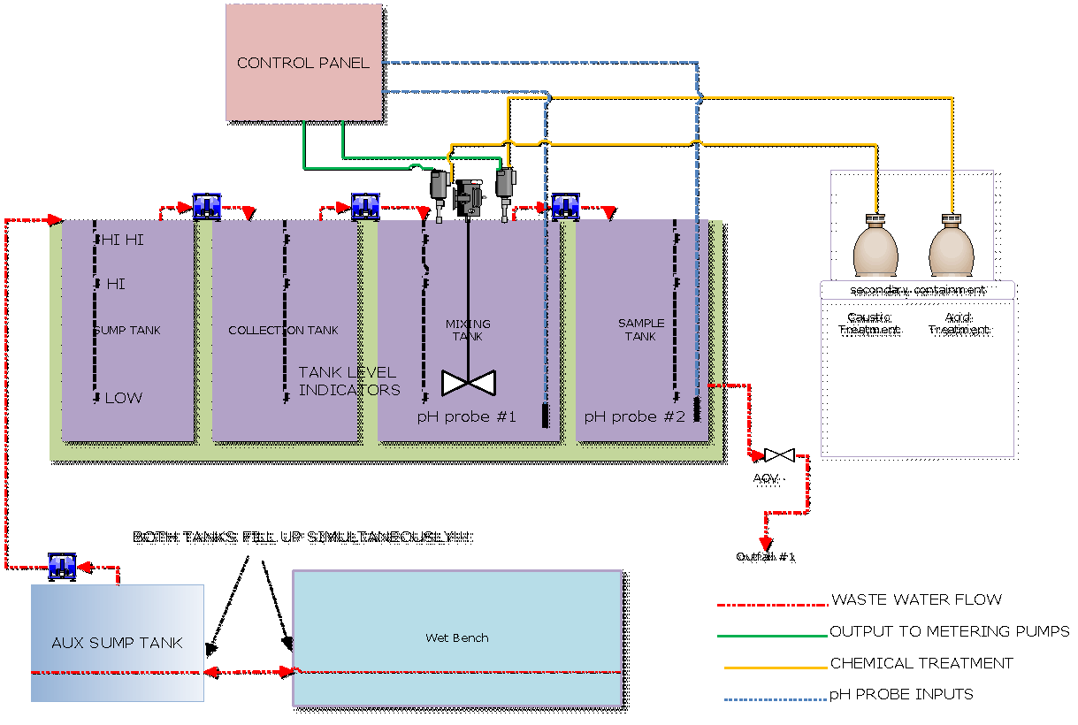

### 

### 5.7.1 Wastewater Management for ET107

All of the waste generated on the wet bench is ultimately routed to the automated neutralization system located in the mechanical room directly behind the IML. The waste stream from this bench first accumulates in a ten gallon lift station. When the level in the lift station reaches a “Hi-on” status the auxiliary transfer pump becomes active, pumping the waste into the eighty gallon tank number one (sump tank). When the level in the tank reaches a “Hi-on” status transfer pump number one begins pumping the waste over to tank number two (collection tank). When the

collection tank sensor reaches a “Hi-on” status, transfer pump number two begins pumping waste to tank number three (Mixing tank). This tank mixes the waste on a timed cycle and doses it with reagent according to the chemical dosing setup and current pH value. This is a batch treatment system which allows no chemicals from entering or exiting the tank after a batch treatment has started until chemical dosing has stopped and the pH value is within the target values which were entered in the Setup screens on the Touch Screen. Once chemical dosing has stopped and the pH value has stayed in the permissible pH range for duration equal to the retention time variable (see setup), it is pumped over to the Sample Tank. Tank number four (sample tank) holds treated wastewater and compares the pH value to that of the effluent pH set points. If the water in the sample tank is within the set point limits, the effluent AOV valve opens and the waste goes to the city sewer. If for some reason the wastewater in the sample tank is not within the set point limits, the valve will not open, the system will alarm and the pH will have to be adjusted manually.

### 5.7.2 Wastewater Management for ET105

Waste plumbing for ET 105 was done with PVC since moderate pH chemicals are used. It consists of flexible PVC tubing from the wafer dicing saw to a sump/settling tank and from the pump tank to the 200 gal. tank. The tank has a flow valve attached to hard PVC pipe to release the neutralized discharge to Outfall 2. The only other potential for spill is DI or City water. Up to 600 gallons of water comes into the Labs daily. It is important to quickly distinguish between a pure water spill and a spill involving any amount of laboratory chemicals. The pure water can be cleaned up with a wet vacuum or with mops. If the spill has the possibility of containing chemicals, it must be cleaned using the spill clean-up kit by trained professionals. **All other personnel should leave the immediate area until The IML Director and the Engineering Technical Services Manager have been contacted or are on site. The IML Director, Manager Engineering Services will then contact BSU Environmental Health and Safety Department.**

The IML Director, Manager Engineering Services will contact the BSU Environmental Health and Safety Department who in turn will provide hazardous waste disposal.

# 6.0 IML COMPRESSED GAS SAFETY

## 6.1 General Compressed Gas Safety Procedures

Cylinders of both toxic and non-toxic compressed gases are in use throughout the lab. Only well trained students or staff may install or disconnect these cylinders. Only trained staff may handle any compressed gas cylinders. There are several reasons for this policy. Some gases are toxic. Some gases in these cylinders are at high pressures, as high as 3000 psi. Regulators are designed to handle specific gases and can explode if not properly chosen. Improper installation or purging will contaminate a full bottle of gas. Some of our etching gases cost hundreds of dollars and their loss or contamination can be costly.

* Gas cylinders must be chained and strapped down at all times.
* Do not bring new gases into IML without approval of the IML Director or PI.
* Handle cylinders of compressed gases as high-energy sources and therefore as potential explosives.
* When storing or moving cylinders, have the protective caps securely in place to protect the valve stems.
* When moving large cylinders, strap them to a properly designed, wheeled cart to ensure stability
* Cylinders must not be dragged or rolled. Cylinders should not lean on one another.
* Restrain cylinders of all sizes, empty or full, individually by straps, chains, or a suitable stand to prevent them from falling.
* Do not expose cylinders to temperatures higher than approximately 50C. Some small cylinders, such as lecture bottles, are not fitted with rupture devices and may explode if exposed to high temperatures.
* Cylinders should be stored in appropriately ventilated closets or in an open storage area.
* Never store a cylinder next to a heat or flame source.
* Do not place gas cylinders such that there is contact with electrical circuitry.
* Never use cylinders that cannot be identified positively.
* Inspect cylinder valves for damage or corrosion prior to use. If unsuitable for use, return to supplier.
* Do not put oil or grease on the high pressure side of any compressed gas cylinder valve. A fire or explosion can result.
* Use the appropriate regulator on each gas cylinder. The threads on the regulators are designed to avoid improper use. Do not use any adapter between the gas cylinder and the regulator.
* Use toxic, flammable, corrosive, or reactive gases in fume hoods only. Post signs in the laboratory area when using any of these type gases.
* Never bleed cylinders completely empty. Leave a slightly positive pressure on the tank to keep contaminants out. (Never heat a compressed gas cylinder to "milk" out the last bit of gas. The base plug softens and it becomes a missile.)
* Remove the regulator from an empty cylinder and replace the protective cap. Mark the cylinder "empty" and place it in the appropriate location for pickup.
* Do not mix gases within a cylinder. If a mixture is required, order it that way from the supplier.
* Never open a cylinder more than 1/2 to 3/4 of 1 turn. This way the cylinder can be turned off quickly in the event of an emergency.
* Review the MSDS sheets for the gasses that you are using. Many of the gasses are toxic. All high pressure gasses, regardless of toxicity, should be treated with respect.
* Before using any gas on any piece of equipment, verify that the gas that you think is connected is the one that actually is connected.
* Always wear safety glasses when handling compressed gases.
* Make sure all cylinders are properly labeled.
* Never direct high pressure gases at a person
* Regulators, gauges, and hoses should not be interchanged among gases.
* Do not place any item on top of a cylinder that could damage a safety device or interfere with quick closing of a valve.

## 6.2 Liquid Nitrogen Handling Safety

Liquid nitrogen is a colorless, odorless liquid with a boiling point of -196oC. At low temperatures the gas / vapor is heavier than air. Small amounts of liquid vaporize rapidly to produce large volumes of gas (1 liter of liquid nitrogen will produce 0.7m3 of gas). Nitrogen gas is invisible - the cloudy vapor which appears when liquid nitrogen is exposed to air is condensed moisture, not the gas itself.

### 6.2.1 Specific Hazards

* Asphyxiation - One of the main dangers associated with liquid nitrogen is the risk of asphyxiation when used or stored in poorly ventilated areas. Liquid nitrogen evolves nitrogen gas which is inert and non-toxic but there is a risk of asphyxiation in situations where high concentrations may accumulate and subsequently displace air from the room. Short exposures to cold gas vapor lead to discomfort in breathing with prolonged inhalation can produce serious affects on the lungs and could possibly provoke an asthma attack.
* Cryogenic burns - Liquid nitrogen can cause cryogenic burns if the substance itself, or surfaces which are or have been in contact with the substance (e.g. metal transfer hoses), come into contact with the skin. Local pain may be felt as the skin cools, though intense pain can occur when cold burns thaw and, if the area affected is large enough, the person may go into shock.
* Frostbite - Continued exposure of unprotected flesh to cold atmospheres can result in frostbite. There is usually sufficient warning by local pain while the freezing action is taking place.

### 6.2.2 Storage

* All liquid nitrogen must be stored in an approved liquid nitrogen container and be periodically inspected. Bulk liquid nitrogen amounts (>200L) are stored in the 1000L storage container located immediately behind ET105. One other storage device is the 200L liquid nitrogen tank located in ET105 for use by the Oxford Etcher.

### 6.2.3 Authorized personnel

* Use of liquid nitrogen by undergraduate students, graduate students requires the consent of the principal investigator after individual training has occurred.
* Use of liquid nitrogen by COEN staff and faculty can be done once individual training has occurred.

### 6.2.4 Training Requirements

* All users of liquid nitrogen must have attended the training lecture on handling LN2 and must show competency regarding the safe handling and use of LN2 prior to use.
* Training must include but is not limited to:
  + General laboratory safety training
  + Review of the liquid nitrogen MSDS
  + Hands on training of dewar usage if applicable
* Personal Protective Equipment (PPE)
  + Hands - non-absorbent insulated gloves must always be worn when handling anything that is or has been in recent contact with liquid nitrogen. Cryogenic gloves are supplied and designed to be used in the vapor phase only and should not be immersed into liquid nitrogen under any circumstances. They should be a loose fit to facilitate easy removal. Gauntlet style gloves are not recommended as liquid can drip into them and become trapped against the skin.
  + Skin - sleeves should cover the ends of gloves or alternatively, a ribbed cuff style may be used.
  + Face - a full face visor, or as a minimum, safety glasses, should be used to protect the eyes and face where splashing or spraying may occur, and in particular, where operations are carried out at eye level as is when filling reservoirs on electron microscopes. Enclosed chemical goggles must not be worn as eye protection. An enclosed goggle could trap liquid nitrogen, increasing the potential contact time with the liquid nitrogen.
* Body - a laboratory coat should be worn at all times. Non-absorbent cryogenic aprons are also commercially available. Open pockets and turn-ups where liquid could collect should be avoided. Trouser bottoms should overlap boots or shoes for the same reason.
* Feet - closed toed shoes are required for handling liquid nitrogen vessels.

### 6.2.5 Transferring and transporting liquid nitrogen

* Make sure that there is good ventilation. Open a door if you are in a small room.
* Use dewars rated for liquid nitrogen.
* Never use a dewar that does not have a pressure relief valve or pressure venting lid/stopper.
* Never use dewars with makeshift or homemade lids/stoppers.
* Use pressure venting lids/stoppers supplied by the dewar manufacturer.
* Dewars larger than 10 Liters will be lifted and poured by two people.
* Do not use a funnel to transfer LN2.

### 6.2.6 Dispensing liquid nitrogen from large storage tanks

* Dispense only into dewars that are rated for liquid nitrogen.
* Dispense only into dewars that are:
  + Equipped with carrying handles or wheels.
  + Stable and not in danger of tipping over easily.
* Persons filling Dewar(s) will be in constant attendance during filling.
* Place filling hose at or below the mouth of the receiving Dewar.

### 6.2.7 Transporting liquid nitrogen between buildings

* Use dewars rated for liquid nitrogen.
* Never Transport liquid nitrogen in an open container.
* Do not use unstable wheeled carts or dewars.
* Avoid grates, large cracks in sidewalks/pavement, or other hazards that could cause tipping

### 6.2.8 Transporting liquid nitrogen within laboratories and between laboratories in the same building

* Use dewars rated for liquid nitrogen.
* Do not transport liquid nitrogen in open container.
* If you are carrying a Dewar containing Liquid Nitrogen:
  + Make sure the dewar is your ONLY load (no books, coffee, other items).
  + Carry transport dewar as far away from your face and body as possible.
  + Watch for other people who may run into or bump you.

### 6.2.9 Decontamination

Refer to active MSDS sheet on file

### 

### 6.2.10 Spills or Leaks

* Large - Immediately leave the space and call 911, the IML Director and the principal investigator.
* If it is a leak from a container or it's valve, leave the space and call the IML Director or PI immediately
* Small – should vaporize in a few seconds.

## 6.3 Use of Liquid Nitrogen as a Coolant in Electron Microscopes and Other Instrumentation

Electron microscopes and other instruments require liquid nitrogen as a coolant and are present in a number of departments throughout the College. It is the accepted practice to fill SEM reservoirs by pouring liquid nitrogen directly from a small hand held dewar since the configuration of these instruments does not easily lend itself to any form of automatic filling (some reservoirs are 7 - 8 feet from floor level). When manually handling liquid nitrogen at such a height, special care is needed and the following precautions should be taken:

* Platform steps with a guard rail should be considered. They should be of sufficient height to enable the reservoir to be filled from above rather than at face level. A number of factors affect the practicality of using ladders, such as the ceiling height and the amount of space available for maneuvering them into place.
* Care must be taken not to introduce additional risks such as tripping over or pulling loose electrical cables. If there is sufficient space to leave the ladder permanently in place behind the instrument then this should be considered. If the height of the ceiling is restrictive and filling must subsequently take place close to face level then it is essential to wear a full face visor. Since there is also a greater risk of liquid nitrogen being spilt down the person’s front, then suitable clothing which minimizes neck and chest exposure and the likelihood of liquid nitrogen being trapped against the skin should be chosen e.g. a pocket less laboratory coat buttoned up so that it comes above the bottom rim of the visor and / or a cryogenic apron.
* While the task is being performed, at least one other person should be present in the vicinity to raise the alarm and assist in the event of a mishap. The second person however, should never stand immediately beneath the person who is filling since they may become a victim themselves if there is a spillage or the flask is dropped.
* The person filling should remain vigilant so that any overflow from the reservoir is strictly limited.
* The hand held dewar should be approved for use with cryogenic substances.

# 

# Appendix A. Idaho Microfabrication Laboratory Layout.

# ET107

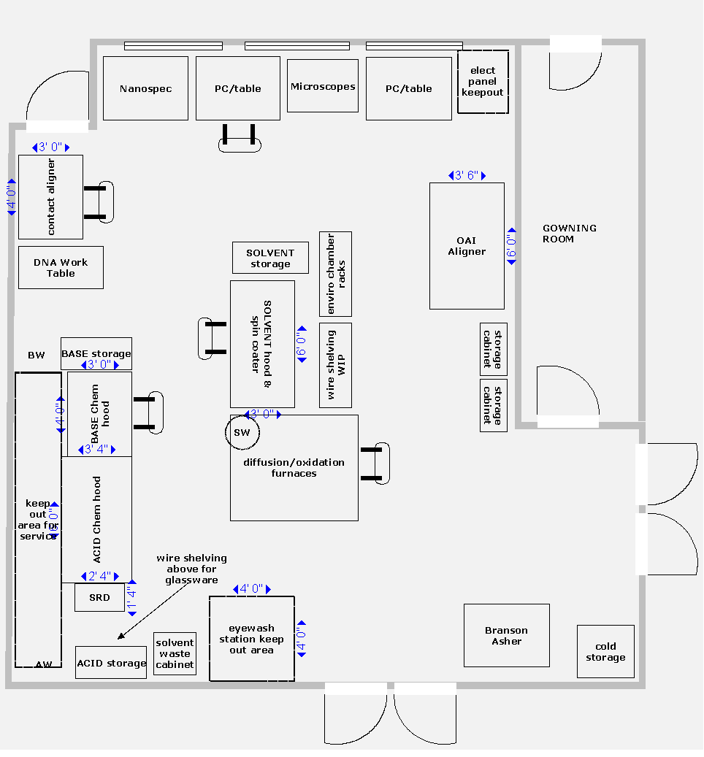

# ET105

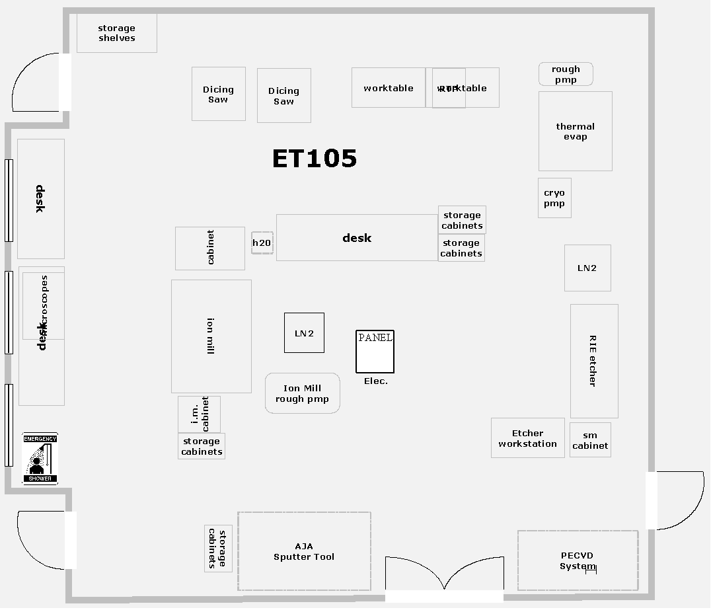

# Appendix B: IML Evacuation Plan.

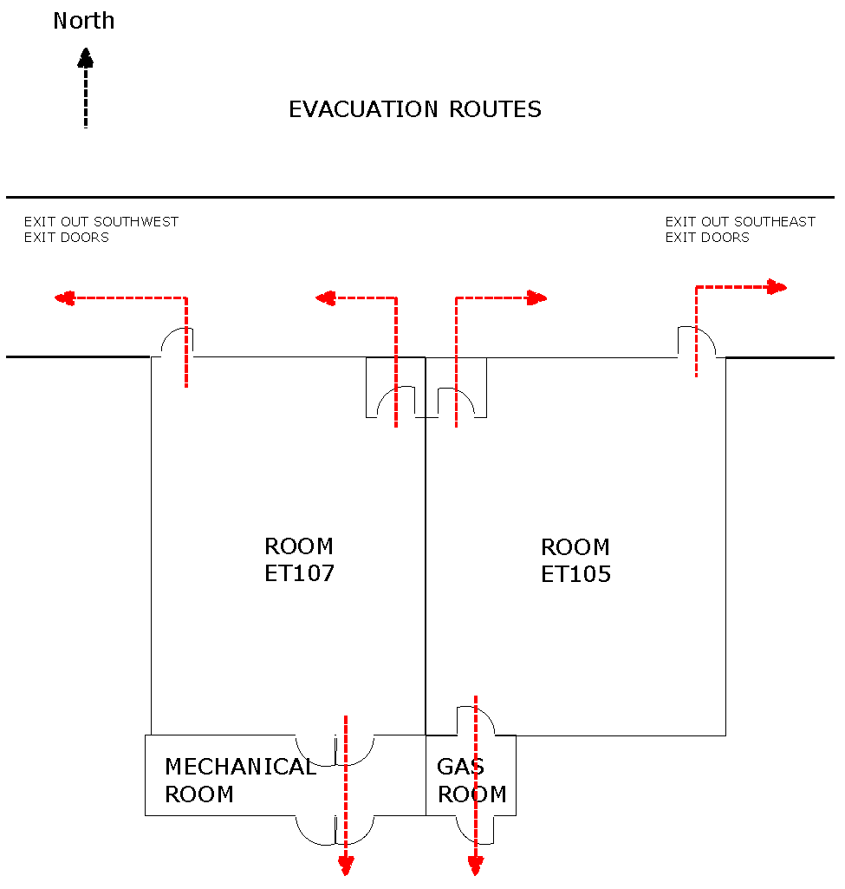

# Appendix C. IML Student Users Agreement.

**Idaho Microfabrication Laboratory**

**Student Users Agreement**

I have been trained in IML safety procedures and I agree to abide by the rules and regulations governing access and use of IML facilities. I understand that I am responsible for ensuring that safety practices are followed while I am in the IML. I also understand that failure to follow written safety and equipment operating procedures can result in my IML access privileges to be revoked indefinitely.

Name_________________________________________________________

Email_________________________________________________________

Advisor’s name and your role in the lab_____________________________

Advisor’s phone number_________________________________________

Area of research or course number_________________________________

Your office/room number and phone number______________________________

Off campus phone number_______________________________________

Who to notify in case of emergency:

Name:____________________________________________________

Relationship:_______________________________________________

Phone Number:_____________________________________________

_______________________________________________

Signed and date

# Appendix D. Common Chemicals Used in the IML.

|  |  |  |  |
| --- | --- | --- | --- |
| **Chemical Type** | **Chemical** | **Formula** | **Concentration** |
| Acids & Oxidizers | Acetic Acid | CH3COOH | 95% |
| Hydrofluoric Acid | HF | 49% |
| Hydrochloric Acid | HCL | 36% |
| Nitric Acid | HNO3 | 68% |
| Phosphoric Acid | H3PO4 | 86% |
| Sulfuric Acid | H2SO4 | 96% |
| Hydrogen Peroxide | H2O2 | 30% |
| Aluminum Etch |  | 80% |
| NANO-STRIP |  | <1% |
| Bases | Ammonium Hydroxide | NH4OH | 25% |
| Ammonium Fluoride | NH4F | 40% |
| Potassium Hydroxide | KOH | 45% |
| Sodium Hydroxide | NaOH | 50% |
| Tetramethylammonium | (CH3)4NOH | 25% |
| Solvents | 2-Propanol | CH3CHOHCH3 | 100% |
| Acetone | CH3COCH3 | 100% |
| Chlorobenzene | C6H5CL | 100% |
| Methanol | CH3OH | 100% |
| Toluene | C6H5CH3 | 100% |
| Trichloroethylene | C2HCL3 | 100% |
| Xylene | C6H4(CH3)2 | 80-90% |

# Appendix E. Chemical Spill Investigation Report

**Spill Investigation Report**

Investigator: ___________________________________________

Date of Spill: _____________ Time of Spill: _____________

Spill Location: _________________________________________

Witnesses to Spill: _________________________________________

_________________________________________

_________________________________________

Description of Spill: pH = _______ Physical Description: □Solid □Liquid Volume:

Did any of the spill material enter the sanitary sewer (drain)? Yes No

If any spill material entered the sanitary sewer, estimate volume:

Chemical Name (s): __________________________________________________

Other Information: _________________________________________________

_________________________________________________________________

Cause: _________________________________________________________________

_______________________________________________________________________

Authorities Contacted: _________________________________________

_________________________________________

_________________________________________

Clean-up Activities (Including Parties Involved): __________________________________

_______________________________________________________________________

_______________________________________________________________________

Lab had adequate equipment to safely and effectively contain and clean up the spill: □Yes □No Improvements to be made: __________________________________________