**ECE 123 Electronics & devices**

**Teaching Lab Safety MANUAL**

|  |  |
| --- | --- |
| Original Author: | Pat Smith |
| Application: | MS Word |
| File Name: | XYZ 123 Teaching LSM 1-21-2016.docx |

**REVISION HISTORY**

|  |  |  |
| --- | --- | --- |
| Rev. | Revision Description | Approved By: |
| 1.0 | As Issued | __________________________________ Dr. Sam Smith, Instructor date |
| __________________________________ Dr. Sally Olsen, Chair date |
| __________________________________ Chris Siepert, COEN Safety Liaison date |
| __________________________________ Dr. Suzy Arnette, date EHSS Lab. Safety Officer |
|  |  |  |

**TABLE OF CONTENTS**

1.0 Scope 3

2.0 Lab Safety Checklist 3

3.0 Emergency Response 4

3.1 Calling 9-1-1 4

4.0 Lab Operations and Hazards 5

4.1 Lab Activities and Associated Hazards 5

4.2 Use of Personal Protective Equipment 5

4.2.1 Use of Safety Glasses 5

4.2.2 Use of Other Personal Protective Equipment (PPE) 6

4.3 Personal Behaviors 6

4.4 Stop Work Practice 6

Appendix A. Laboratory Evacuation 7

Appendix B. Add Additional Content Below As Needed 22

|  |  |
| --- | --- |
| Scope | This document is intended to provide safety information on the safety equipment, activities and hazards specific to the space(s) used by this lab course. This document is intended to be used in conjunction with other lab safety training that may be provided.  It is mandatory that all individuals who perform work in the lab be fully aware of this document’s existence, understand its contents, and satisfy the testing requirements associated with it. This burden of knowledge and training is the shared responsibility of the Instructor, teaching assistants and students.  **NOTE**: Instructors and TAs must also be familiar with the content in the COEN General Teaching Lab Safety Supplement. |

|  |  |
| --- | --- |
| Lab Safety Checklist | Below is a checklist of important safety-related information for your lab space(s). **Familiarize yourself with this information. See Appendix A Laboratory Evacuation for more information.**    **Lab Location: MEC 415, MEC 407**  Building Address: 1020 Manitou Ave.  Lab Phone Number: 208-426-5661 (MEC 415)  Important Safety-Related Locations:  Secondary Contact Info: Lab entrances  Lab Safety Notebook: Near MEC 415 exit  Nearest Fire Extinguisher: MEC 415 (near exit), MEC 407 (on east wall)  Nearest Fire Blanket: Near south exit of MEC 415  Nearest First Aid Kit: Near south exit of MEC 415  Nearest Eyewash/Safety Shower: MEC 415 near exit  Nearest Chemical Spill Kit: MEC 415 north wall  Nearest AED: MEC 2nd floor opposite elevator  Nearest Fire Alarm Pull: At north & south stairwells, MEC 4th floor  Nearest Phone: MEC 4th floor adjacent to elevator  Safe Assembly Area For Evacuation: Parking lot of ENGR Bldg.  Meet 1st Responders: On Manitou Ave. |

|  |  |
| --- | --- |
| Emergency Response | |
| Calling 9-1-1 | * **If possible, first get out of immediate danger.** * **To report any medical emergency or fire, call 9-1-1 from any phone.** * **In the event of a fire, or if you feel the building’s occupants are in danger:**   + Activate the building’s fire alarm system before calling 9-1-1. Evacuate the building immediately!   + If your building does not have fire alarm pulls, call University Security & Police at 426-6911 so that the alarm may be remotely activated.   For other emergencies, contact University Security & Police at 426-6911.  When calling 9-1-1:   * Stay on the line with the dispatcher. * Provide the address of the building involved and your exact location when calling from a cell phone. The building address is located on the Emergency Contact sign on the door of your lab. * Provide a thorough description of the incident to ensure that proper resources are dispatched. * Do not hang up until the dispatcher tells you to do so.   Follow up the 9-1-1 call with a call to University Security & Police at 426-6911. |

|  |  |
| --- | --- |
| Lab Operations and Hazards | |
| Lab Activities and Associated Hazards | The activities and hazards of this lab include the following:   MEC 415:  Lab Activities:   * Setting up passive and active circuits * Measure electrical characteristics of circuits and devices   Associated Hazards:   * Thermal (soldering) * Exposure to flux * Eye injury when snipping wires   HML High Bay Area:  Lab Activities:   * Wind tunnel experiment   Associated Hazards   * Flying debris entrained in air flow * Air flow knocking over items downstream   **Note:** Hazards relating to the activities and experiments in this course must be described in the procedures for those activities. Consult these protocols or your instructor or T/A if you have any question on how to perform the work that is requested. |
| Use of Personal Protective Equipment | PPE should be considered the last avenue in providing work protection and be implemented if elimination, substitution, and engineering and administrative controls cannot provide sufficient protection. |
| Use of Safety Glasses | Any process that may generate flying debris requires the use of safety glasses to be worn by all in proximity of the work. These processes include-   * Setting up components in wind tunnel, even when tunnel is off * Working around tunnel when tunnel is on * Power grinding and sanding * Any other process that yields flying debris |
| Use of Other Personal Protective Equipment (PPE) | Other PPE may be required as specified by the procedure for their respective lab activity. |
| Personal Behaviors | * All people working in the lab must be familiar with the hazards of the materials with which they are working. * No food or drink is permitted in the lab. * No unauthorized experiments. * No student or teaching assistant may work in the lab unless they have pre-approval from their instructor. * No rough-housing is permitted in the lab. * When performing an operation, consider if those nearby require additional personal protective equipment and take appropriate measures. * Employ good housekeeping rules by maintaining a clean, uncluttered work area. |
| Stop Work Practice | A student should never perform a job if they   * Do not believe it to be safe * Do not fully understand the activity or lack proper training * Do not believe adequate personal protective equipment (PPE) is available.   In these cases, the student should consult with the instructor or teaching assistant to resolve the concern before continuing work. |

###### Laboratory Evacuation

**When ordered to evacuate or when alarms are activated, ALWAYS LEAVE IMMEDIATELY.**

* Unless ordered otherwise by officials, designated Building Coordinators and/or alternates and assistants (identified with red armbands) shall direct and ensure, to the extent practical, that a safe personnel evacuation is conducted. Treat all alarms as warning of an actual emergency situation.
* All department heads, faculty, managers and supervisors must help direct employees, students, visitors and each other to obey evacuation instructions of emergency response personnel and/or the Building Coordinators.
* Building Coordinators and/or alternates and assistants shall notify emergency personnel immediately upon their arrival at the scene concerning the status of the evacuation, the exact location of any injured or trapped persons, those waiting in designated Areas for Evacuation Assistance, any others who may be anywhere in the building, and any other relevant information on the emergency situation.

**Exit quickly and calmly using nearest emergency escape routes and marked exits and proceed to Safe Assembly Locations.  DO NOT USE ELEVATORS!**

* Do not attempt to use elevators during an emergency.  Elevators are called to the first floor when the fire alarm system is activated.  Use only stairways in an evacuation.
* Use clear, safe escape routes and exits and proceed to the nearest outside Safe Assembly Location shown on this building’s posted evacuation map, or to a location ordered by emergency response personnel.  Do not return to an evacuated building until directed by University officials.
* If possible, take your coat and keys but do not take time to go to lockers or offices for personal possessions.
* Where applicable and, if possible and safe, turn off laboratory gases, exhaust fans, and close doors/windows as you exit.

**Assist persons requiring evacuation assistance to get to designated Areas for Evacuation Assistance.  Be alert for trapped, injured, or other persons requiring assistance.**

* Transporting of individuals requiring evacuation assistance up or down stairwells shall be avoided until emergency response personnel have arrived.  Unless imminent life-threatening conditions exist, relocation of these individuals shall be limited to the designated Areas for Evacuation Assistance.
* Notify emergency personnel immediately upon their arrival of the exact location of any injured or trapped persons, those waiting in designated Areas for Evacuation Assistance, and any others who may be anywhere in the building.

Evacuation & Safety Equipment Map-

**Engineering Bldg, 1st Floor**

****Evacuation & Safety Equipment Map-

**Safe**

**Assembly**

**Location:**

**ENGR Building**

**Parking Lot**

**N**

**Fire Alarm Pull Station**

**Fire Extinguisher\***

**AED- MEC 2nd Floor, Opposite Elevator**

**Emergency Phone**

**Evacuation**

**Assistance Area**

* lab extinguishers  
 not shown.

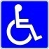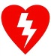

**Engineering Bldg, 2nd Floor**



Evacuation & Safety Equipment Map-

**Safe**

**Assembly**

**Location:**

**ENGR Building**

**Parking Lot**

**N**

**Fire Alarm Pull Station**

**Fire Extinguisher\***

**AED- MEC 2nd Floor, Opposite Elevator**

**Emergency Phone**

**Evacuation**

**Assistance Area**

* lab extinguishers  
 not shown.



**Engineering Bldg, 3rd Floor**Evacuation & Safety Equipment Map-



**Safe**

**Assembly**

**Location:**

**ENGR Building**

**Parking Lot**

**N**

**Fire Alarm Pull Station**

**Fire Extinguisher\***

**AED- MEC 2nd Floor, Opposite Elevator**

**Emergency Phone**

**Evacuation**

**Assistance Area**

* lab extinguishers  
 not shown.



**Micron Engineering Center, 1st Floor**

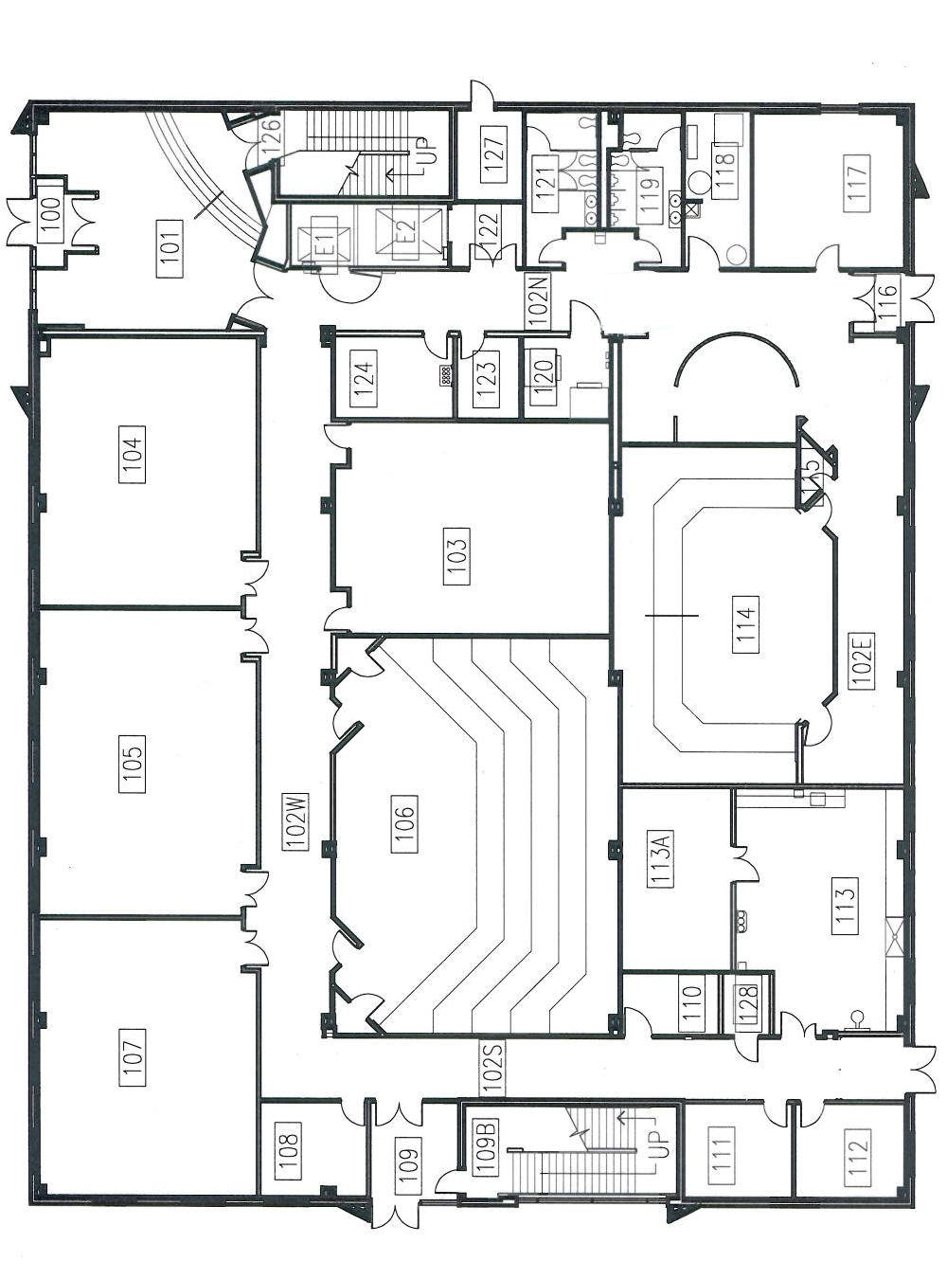

**Safe**

**Assembly**

**Location:**

**ENGR Building**

**Parking Lot**

**N**

**Fire Alarm Pull Station**

**Fire Extinguisher\***

**AED- MEC 2nd Floor, Opposite Elevator**

**Emergency Phone**

**Evacuation**

**Assistance Area**

* lab extinguishers  
 not shown.



Evacuation & Safety Equipment Map-

**Micron Engineering Center, 2nd Floor**

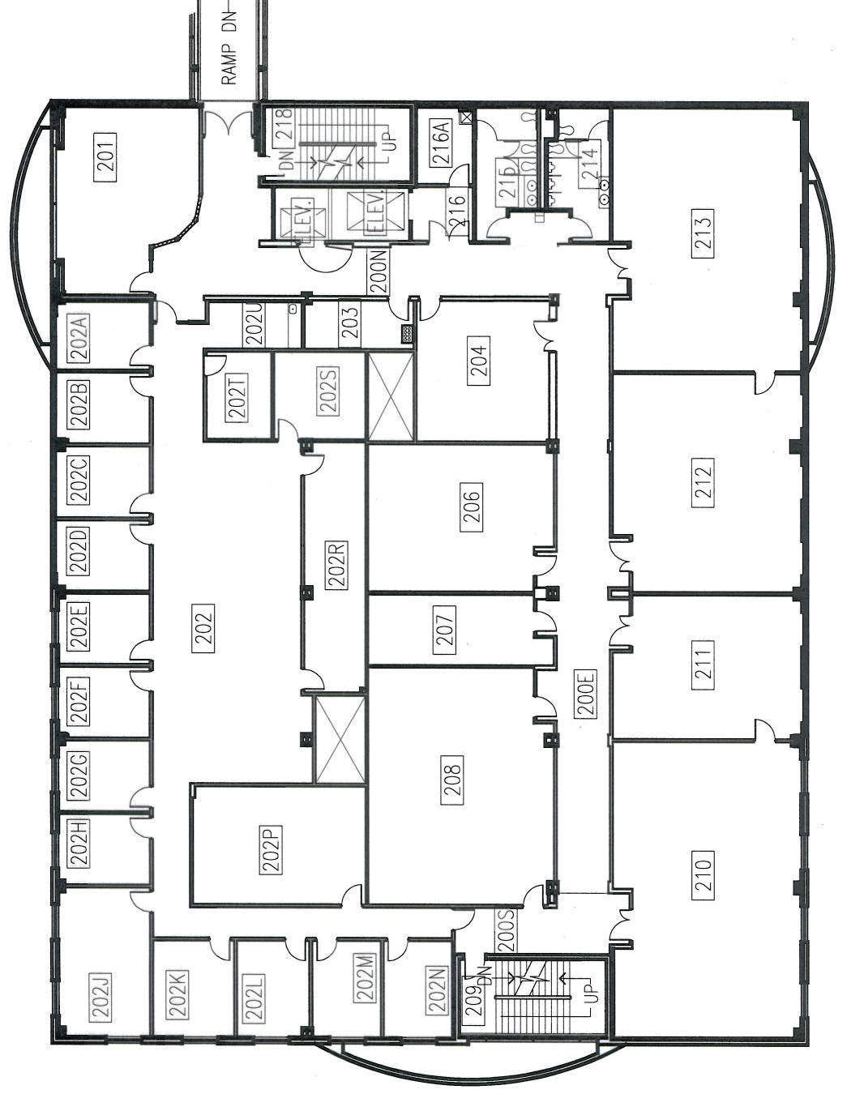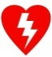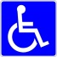

**Safe**

**Assembly**

**Location:**

**ENGR Building**

**Parking Lot**

**N**

**Fire Alarm Pull Station**

**Fire Extinguisher\***

**AED- MEC 2nd Floor, Opposite Elevator**

**Emergency Phone**

**Evacuation**

**Assistance Area**

* lab extinguishers  
 not shown.



Evacuation & Safety Equipment Map-

**Micron Engineering Center, 3rd Floor**

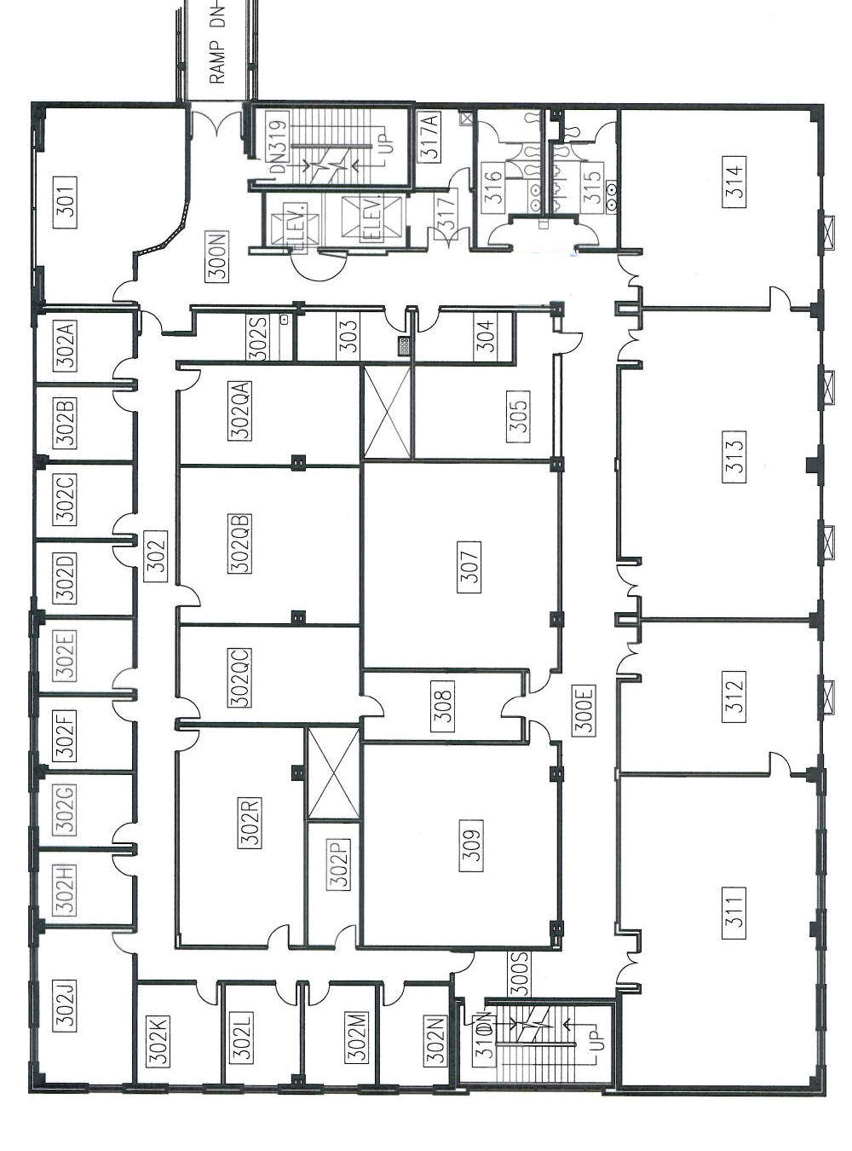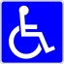

**Safe**

**Assembly**

**Location:**

**ENGR Building**

**Parking Lot**

**N**

**Fire Alarm Pull Station**

**Fire Extinguisher\***

**AED- MEC 2nd Floor, Opposite Elevator**

**Emergency Phone**

**Evacuation**

**Assistance Area**

* lab extinguishers  
 not shown.



Evacuation & Safety Equipment Map-

**Micron Engineering Center, 4th Floor**

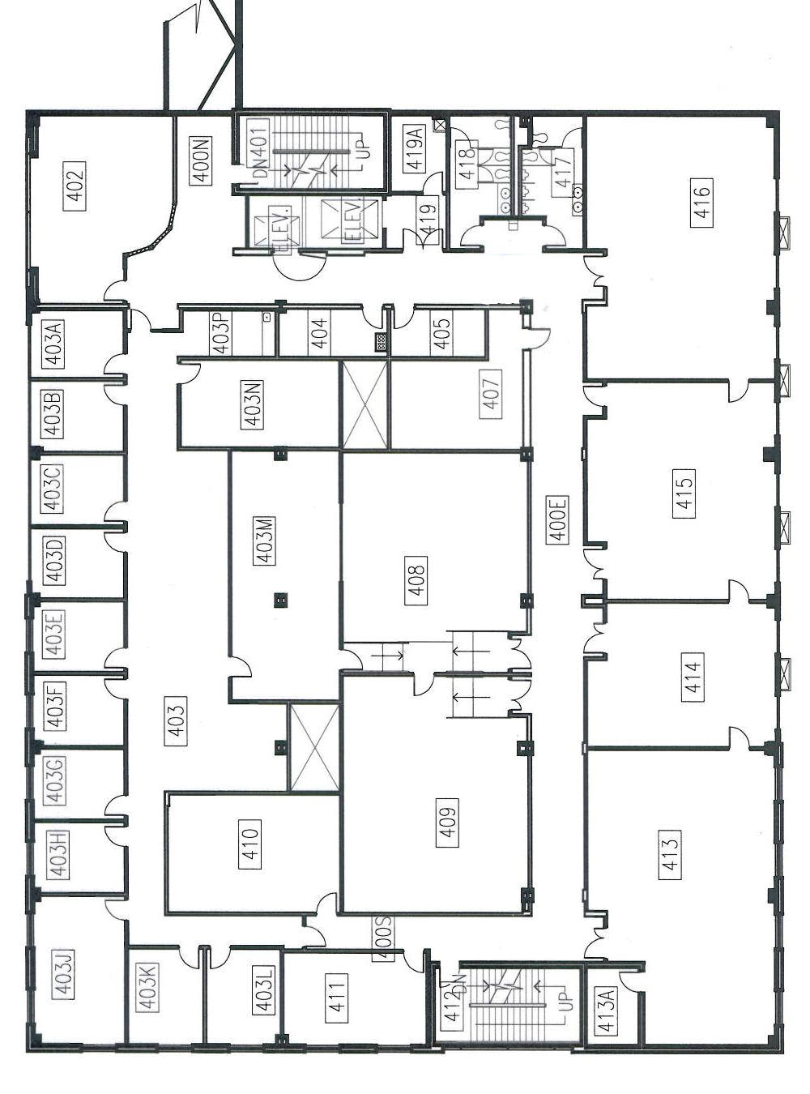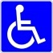

Q.1

Q.2

Q.3



**Safe**

**Assembly**

**Location:**

**ENGR Building**

**Parking Lot**

**N**

**Fire Alarm Pull Station**

**Fire Extinguisher\***

**AED- MEC 2nd Floor, Opposite Elevator**

**Emergency Phone**

**Evacuation**

**Assistance Area**

* lab extinguishers  
 not shown.



Evacuation & Safety Equipment Map-

**HML Bldg, 1st Floor**

Evacuation & Safety Equipment Map-

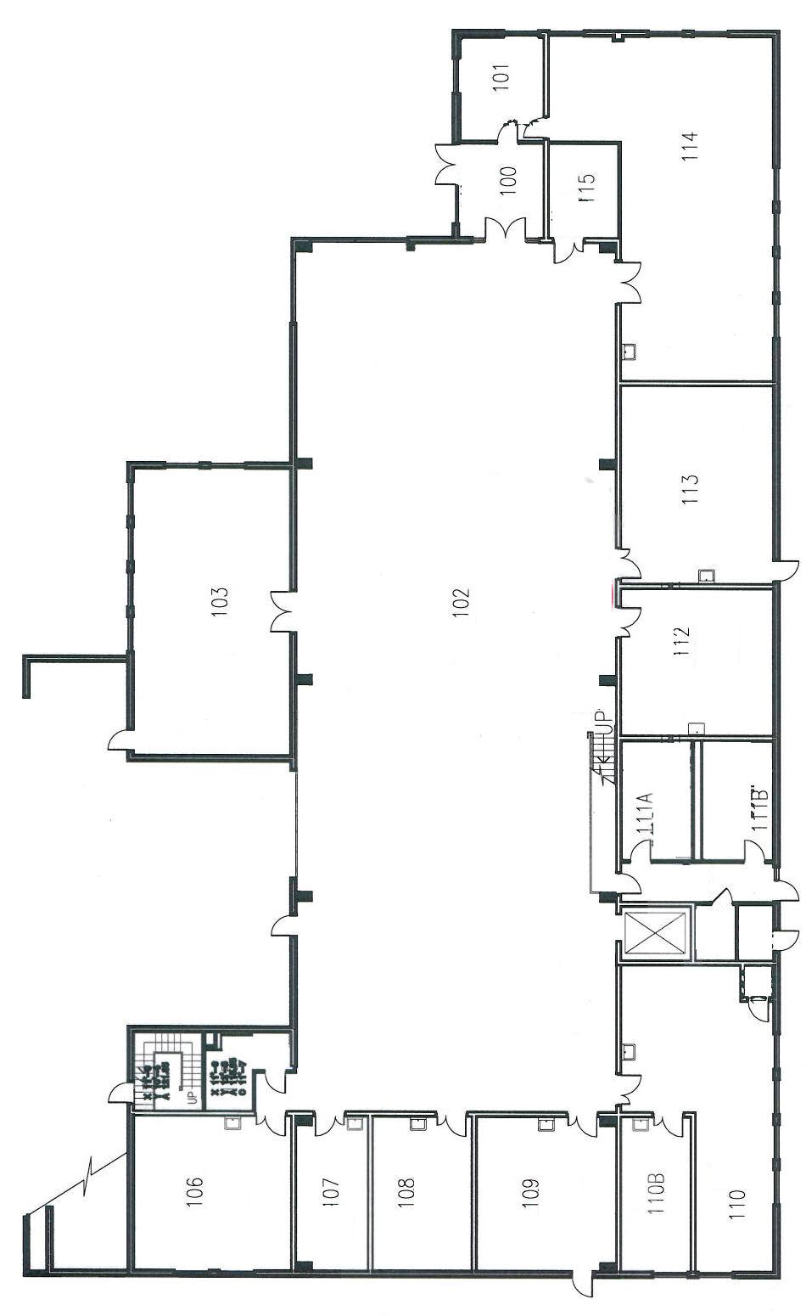

**Fire Alarm Pull Station**

**Fire Extinguisher\***

**AED- MEC 2nd Floor, Opposite Elevator**

**Emergency Phone**

**Evacuation**

**Assistance Area**

* lab extinguishers  
 not shown.



**N**

**Safe**

**Assembly**

**Location:**

**ENGR Building**

**Parking Lot**

**HML Bldg, 2nd Floor**

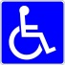**Fire Extinguisher DS**Evacuation & Safety Equipment Map-

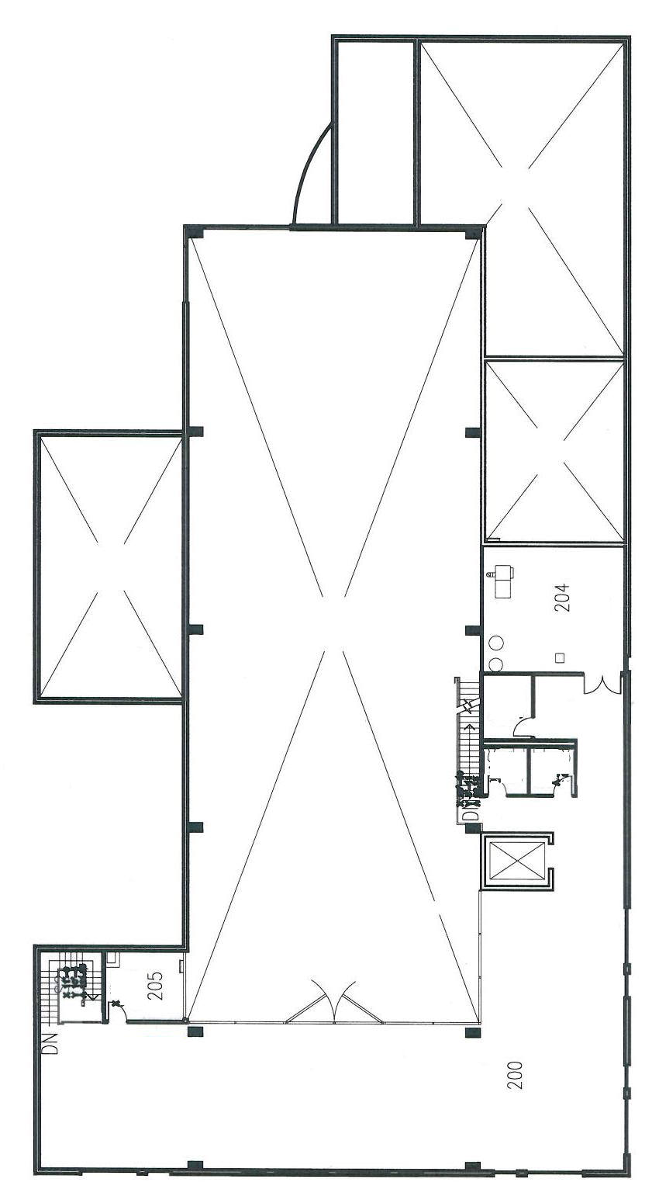

**N**

Fire Alarm Pull Station

Fire Extinguisher*

AED- MEC 2nd Floor, Opposite Elevator

Emergency Phone

Evacuation

Assistance Area

* lab extinguishers  
 not shown.



**Safe**

**Assembly**

**Location:**

**ENGR Building**

**Parking Lot**

**Environmental Research Bldg, 1st Floor**Evacuation & Safety Equipment Map-  
**Environmental Research Bldg, 2nd Floor**

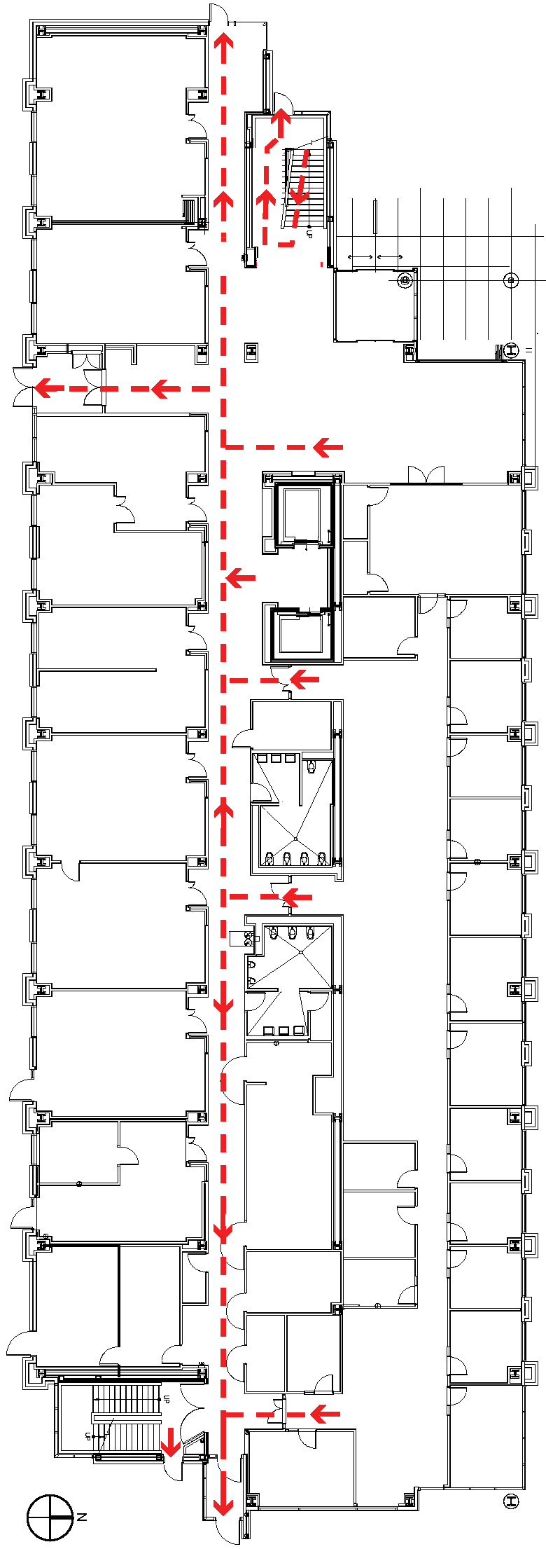

**Safe**

**Assembly**

**Location:**

**Corner of University & Euclid**

**N**

**Note: There are no fire alarm pulls in this building**

**Fire Extinguisher\***

**AED- MEC 2nd Floor, Opposite Elevator**

**Emergency Phone**

**Evacuation**

**Assistance Area**

* lab extinguishers  
 not shown.

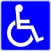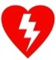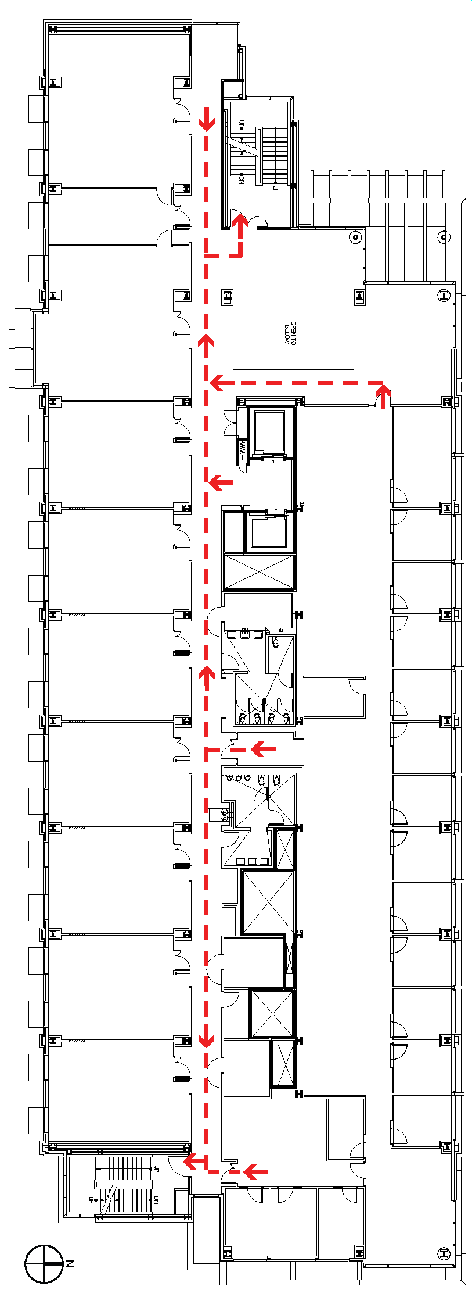

**Safe**

**Assembly**

**Location:**

**Corner of University & Euclid**

**N**

**Note: There are no fire alarm pulls in this building**

**Fire Extinguisher\***

**AED- MEC 2nd Floor, Opposite Elevator**

**Emergency Phone**

**Evacuation**

**Assistance Area**

* lab extinguishers  
 not shown.



Evacuation & Safety Equipment Map-

**Environmental Research Bldg, 3rd Floor**Evacuation & Safety Equipment Map-

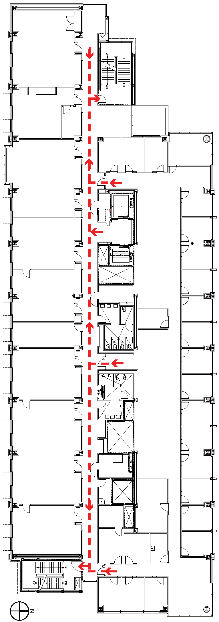

**Safe**

**Assembly**

**Location:**

**Corner of University & Euclid**

**N**

**Note: There are no fire alarm pulls in this building**

**Fire Extinguisher\***

**AED- MEC 2nd Floor, Opposite Elevator**

**Emergency Phone**

**Evacuation**

**Assistance Area**

* lab extinguishers  
 not shown.



**Environmental Research Bldg, 4th Floor**Evacuation & Safety Equipment Map-

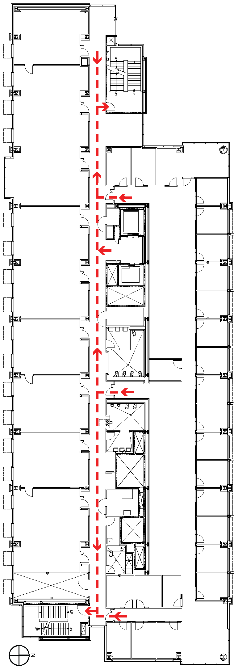

**Safe**

**Assembly**

**Location:**

**Corner of University & Euclid**

**N**

**Note: There are no fire alarm pulls in this building**

**Fire Extinguisher\***

**AED- MEC 2nd Floor, Opposite Elevator**

**Emergency Phone**

**Evacuation**

**Assistance Area**

* lab extinguishers  
 not shown.



**Environmental Research Bldg, 5th Floor**

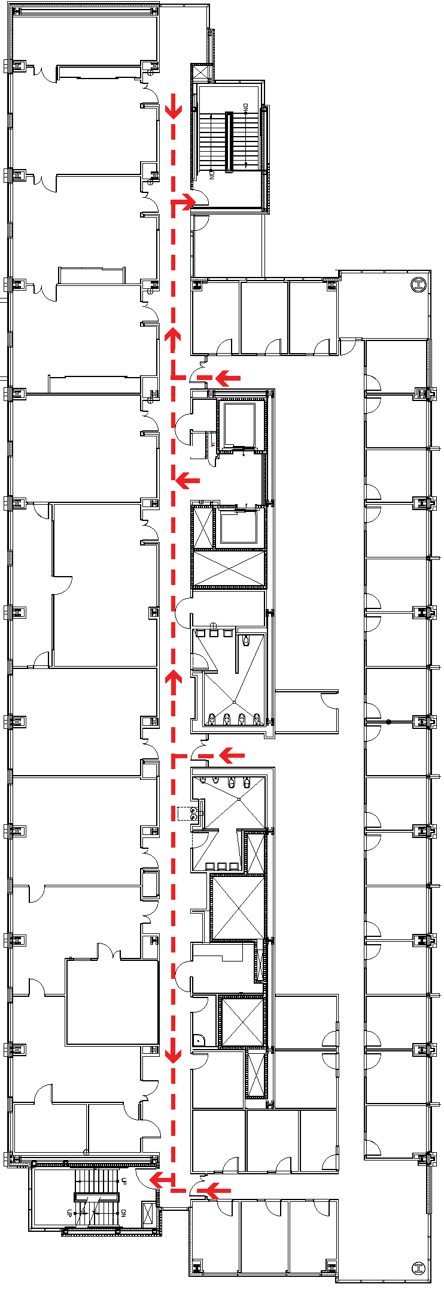

**Safe**

**Assembly**

**Location:**

**Corner of University & Euclid**

**N**

**Note: There are no fire alarm pulls in this building**

**Fire Extinguisher\***

**AED- MEC 2nd Floor, Opposite Elevator**

**Emergency Phone**

**Evacuation**

**Assistance Area**

* lab extinguishers  
 not shown.







###### Add Additional Content Below As Needed