**Boise State University**

**Invention Disclosure Form Instructions**

1. The Invention Disclosure Form (“**IDF**”) is the first step in a process that could potentially lead to commercialization of your technology. It is designed to elicit information to aid in the reporting of inventions to appropriate outside parties, in evaluating whether to pursue patent protection for the invention, and gathering information on potential licensing opportunities.
2. In completing the IDF, please use layperson’s language, but be aware the form is an important legal document. Care should be taken in its preparation. The information contained in the document is maintained in confidence by the Vice President for Research and Economic Development (“**VPRED**”) and the Office of Technology Transfer (“**OTT**”), and normally will not be released to others except with attorney-client privilege, to research sponsors as required by contract, or under appropriate secrecy agreements, until a patent application is filed, the information is published, a determination not to file a patent application is made, or as may be required by law. The information contained herein should not be disclosed to others outside the University without the approval of VPRED or OTT.
3. Use the following guidelines while completing the IDF:

* Provide as much detailed information about the technology as possible, citing all relevant sponsorship and publication information. This enables VPRED/OTT and inside/outside counsel to determine if patent protection is appropriate for the technology, as well as identify possible opportunities for commercialization.
* When identifying inventors, use the broadest spectrum possible. OTT and counsel will work with you to determine legal inventorship.

1. A Word version template is provided for your convenience; **do not edit the template.**
2. Return the completed and fully signed form (including witness signature) and requested documentation to OTT at [techtransfer@boisestate.edu](mailto:techtransfer@boisestate.edu).

**Process Diagram:** Inventors’ steps in blue — OTT’s steps in orange.

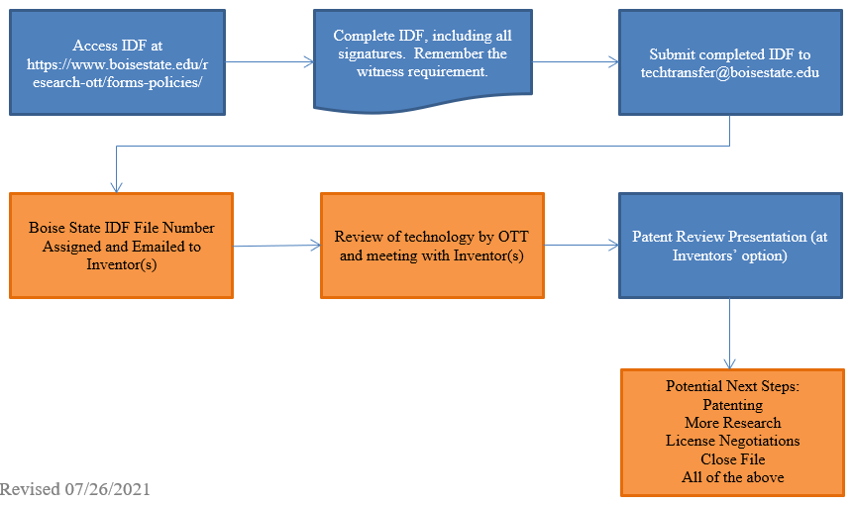

For more information, please visit our website at <https://www.boisestate.edu/research-ott/forms-policies/>.

**Boise State University**

**Invention Disclosure Form**

The Invention Disclosure Form (“**IDF**”) is the first step in a process that could potentially lead to commercialization of your technology. It is designed to elicit information to aid in the reporting of inventions to appropriate outside agencies and in the evaluation of whether to pursue patent protection for the invention.

In completing the IDF, please use layperson’s language, but be aware the form is an important legal document. Care should be taken in its preparation. The information contained in the document is maintained in confidence by the Vice President for Research and Economic Development (“**VPRED**”) and the Office of Technology Transfer (“**OTT**”), and normally will not be released to others except with attorney-client privilege, to research sponsors as required by contract, or under appropriate secrecy agreements, until a patent application is filed, the information is published, a determination not to file a patent application is made, or as may be required by law. The information contained herein should not be disclosed to others outside the University without the approval of VPRED or OTT

Use the following guidelines while completing the CWDF: (1) Provide as much detailed information about the technology as possible, citing all relevant sponsorship and publication information. This enables VPRED/OTT and inside/outside counsel to determine if patent protection is appropriate for the technology, as well as identify possible opportunities for commercialization. (2) When identifying inventors, use the broadest spectrum possible. OTT and counsel will work with you to determine legal inventorship.

Please expand this form as necessary.

1. **Invention Title**

[Add Text Here]

1. **Description**

Provide a short, general layperson’s overview of the invention and how it works.

[Add Text Here]

1. **Technical Description, Details and Supporting Data**

Provide results, data, or other evidence demonstrating how the invention works. Any papers or visual material that you may already have, published or unpublished, should be attached as an answer to this question.

[Add Text Here]

1. **Dates of conception and reduction to practice**

It is important for us to document these dates should any challenges to the patent ever arise. **Conception** is the formulation in the mind of the inventors of the ultimate working invention. **Reduction to practice** can be accomplished either “actually” or “constructively.” Actual reduction to practice is the physical creation of the invention. Constructive reduction to practice is a detailed written description that demonstrates the invention will work as conceived. Describe the circumstances and dates surrounding development of your invention:

**4(a). Conception of Invention (date and details). Is this date documented in writing? If so, where?**

[Add Text Here]

**4(b). First reduction to practice (date and details):**

[Add Text Here]

1. **Is work on the subject of this disclosure continuing?** Are there limitations to be overcome or other tasks to be done prior to practical application? Are there any test data? Describe the stage of development (concept only, laboratory tested, prototype, etc.) and briefly indicate what further development may be necessary to commercialize it.

[Add Text Here]

1. **Why is the subject of this disclosure better or more advantageous than present technology?** What are its

novel or unusual features? What problems does it solve?

[Add Text Here]

1. **What are the immediate and/or future applications?**

[Add Text Here]

7a. Identify companies/organization that you think could benefit from the use of this invention.

[Add Text Here]

7b. Provide any market research and information related to potential licensing opportunities that you’ve identified.

[Add Text Here]

1. **Have any of the inventors disclosed this invention? Disclosures include, but are not limited to, an abstract, paper, talk, presentation at a conference or conversations at a conference, news story or thesis, or to an industrial representative.**

[Add Text Here]

* Type of disclosure (please provide a copy):

[Add Text Here]

* Disclosure date:

[Add Text Here]

* Names or companies and their representatives:

[Add Text Here]

1. **Is publication or other disclosure planned in the next six months?**

[Add Text Here]

* Type of disclosure:

[Add Text Here]

* Anticipated publication date:

[Add Text Here]

1. **Has there been any public use or offers for sale of products embodying the subject of this disclosure?**

Describe and give dates:

[Add Text Here]

1. **Are you aware of related developments by others, such as other research institutions or companies?**  If yes, please give citations. Please provide copies of relevant abstracts or publications.

[Add Text Here]

# Does the invention contain, reveal, or make use of information that was received from an external source under a Confidential Disclosure Agreement? Please provide details:

[Add Text Here]

1. **Was the invention created with use of, or does it have a continuing dependence on, tangible material, including biological material, that was received from an external source under a Material Transfer Agreement?** Please provide details.

[Add Text Here]

1. **Was the invention made with use of, or does it have a continuing dependence on, tangible material,**

**including biological material, that was received from an external source under a Material Transfer**

**Agreement?** Please provide details:

[Add Text Here]

1. **Was the invention conceived in the performance of work under any sponsorship (sponsorship can be in the form of a sponsored research agreement, grant or contract from a government agency such as NIH, NSF, etc., corporation, or not-for-profit private foundation)?** Obligations to such sponsors may exist. Please provide the following information for each sponsor:

[Add Text Here]

|  |  |  |  |  |  |
| --- | --- | --- | --- | --- | --- |
| **External or Internal Sponsor** | **Sponsor Name** | **Contract/Grant Number** | **Principal Investigator** | **Period of Funding** | **OSP Proposal Number or Dept. ID** |
| External  Internal | [Add Text Here] | [Add Text Here] | [Add Text Here] | [Add Text Here] | [Add Text Here] |
| External  Internal | [Add Text Here] | [Add Text Here] | [Add Text Here] | [Add Text Here] | [Add Text Here] |
| External  Internal | [Add Text Here] | [Add Text Here] | [Add Text Here] | [Add Text Here] | [Add Text Here] |
| External  Internal | [Add Text Here] | [Add Text Here] | [Add Text Here] | [Add Text Here] | [Add Text Here] |

**If no contract or grant, was there significant use of BSU administered funds or facilities?** Inventions developed by employees either in conjunction with or aside from their University employment with assistance from University funds, or assistance from University staff, equipment, or facilities shall be the property of the inventor but licensed to the University. The minimum terms of such license shall grant the University the right to use the invention in its internally administered programs of teaching, research, and public service on a perpetual, royalty-free, and non-exclusive basis. The University shall be entitled to a share in any royalties from the work. **Disclosure of Boise State University resources is required. Failure to fully and accurately disclose the use of Boise State University resources may result in sanctions up to and including dismissal from employment.** Please refer to [University Intellectual Property Policy No. 1090](https://www.boisestate.edu/policy/governance-legal/intellectual-property/)for guidelines.

Was this invention developed with University resources?

No,  Yes**.**  If yes**,** list details:

[Add Text Here]

**Contributors to the Invention**

List all those who helped contribute to the conception of the ultimate working invention. The people you include ultimately may or may not be legal inventors. **The contributors to whom correspondence should be sent should be marked with an asterisk and complete contact information should be provided.** If any person holds a sole or joint appointment with any other university, company, or governmental agency, please note that fact. Attach additional sheets as needed.

**Primary Contributor:**

|  |  |
| --- | --- |
| Last Name | [Add Text Here] |
| First Name: | [Add Text Here] |
| Employer: | [Add Text Here] |
| Department: | [Add Text Here] |
| Work Phone Number: | [Add Text Here] |
| Email Address: | [Add Text Here] |
| Campus Mail Stop: | [Add Text Here] |
| Home Address: | [Add Text Here] |
| Home Phone Number: | [Add Text Here] |
| Approximately what percentage of the overall invention was created by you? (Percentage created by you and all co-inventors cannot exceed 100%.) | [Add Text Here] |

**Co-Contributors:**

|  |  |
| --- | --- |
| Last Name | [Add Text Here] |
| First Name: | [Add Text Here] |
| Employer: | [Add Text Here] |
| Department: | [Add Text Here] |
| Work Phone Number: | [Add Text Here] |
| Email Address: | [Add Text Here] |
| Campus Mail Stop: | [Add Text Here] |
| Home Address: | [Add Text Here] |
| Home Phone Number: | [Add Text Here] |
| Approximately what percentage of the overall invention was created by you? (Percentage created by you and all co-inventors cannot exceed 100%.) | [Add Text Here] |

|  |  |
| --- | --- |
| Last Name | [Add Text Here] |
| First Name: | [Add Text Here] |
| Employer: | [Add Text Here] |
| Department: | [Add Text Here] |
| Work Phone Number: | [Add Text Here] |
| Email Address: | [Add Text Here] |
| Campus Mail Stop: | [Add Text Here] |
| Home Address: | [Add Text Here] |
| Home Phone Number: | [Add Text Here] |
| Approximately what percentage of the overall invention was created by you? (Percentage created by you and all co-inventors cannot exceed 100%.) | [Add Text Here] |

Each inventor must sign and date this IDF. **Additionally, the disclosure must then be read and signed by a witness who understands it.**

**Signature of Primary Contributor:**

___________________________________________

Signature

[Add Text Here]

___________________________________________

Typed or Printed Name

[Add Text Here]

___________________________________________

Date

**Witness Signature (REQUIRED):**

Disclosed to and understood by me this [Day]

day of [Month], 20[Year].

___________________________________________

Signature

[Add Text Here]

_________________________________________

Typed or Printed Name

Department Chair, Business Manager, or other employee familiar with Department resources used who can verify whether significant University resources were used.

**Signatures of Additional Contributors:**

___________________________________________

Signature

[Add Text Here]

___________________________________________

Typed or Printed Name

[Add Text Here]

___________________________________________

Date

___________________________________________

Signature

[Add Text Here]

___________________________________________

Typed or Printed Name

[Add Text Here]

___________________________________________

Date

**Please email a PDF copy of this IDF and all supporting documents to** [**techtransfer@boisestate.edu**](mailto:techtransfer@boisestate.edu)**.**